Abstract
The rapid evolution of computer science has led to applications that are high-demanding in computer resources. Different organisations can share distributed resources in a collaborative manner in order to form Computational Grids. A lot of effort is being paid world-wide for a common grid infrastructure to be adopted by all countries. Greece is participating actively in this movement and projects are already on track for the establishment of a national greek grid. The purpose of this project is to build a grid enabled prototype system that will distribute highly intensive in computing power applications to many computers. The programming language that is used is Java. A lot of architectures and frameworks exist that can be used for the design and implementation of this system. The architecture that was deemed more appropriate was the Master-Worker design pattern and the framework that was used was Jini in conjunction with the JavaSpaces service that it provides. The system was designed under the light of software engineering design principles and patterns in order to be easily extensible, scalable and efficient. A third party raytracing engine was used for the evaluation of the system.

1 Introduction
The rapid evolution of computer science has led to applications that are high-demanding in computer resources. Although the power of personal computers has been increased dramatically during the recent years it is still not enough for many applications especially scientific ones. Except form that of the computing resources another issue arises in the field of data storage (Casanova, 2002). Modern applications can operate on and generate petabytes of data (Bethke et al, 2001). Applications like SETI@home, DNA and further medical research, key decryption and computer graphics are only a few examples of applications highly intensive in computing resources and data storage. It has been stated that the power of network, storage and computing resources is doubled every nine, twelve and eighteen months respectively (Foster, 2002). Creating a centralised system to satisfy the needs of these applications is very difficult and sometimes impossible if you consider the cost of super-computers. That is why scientists have tried to create platforms that will cover the demands of those applications by breaking the barriers of central, isolated computers. These platforms should be highly distributed, easily scalable, secure and heterogeneous (Hellas Grid Task Force, 2003). The evolution of networks gave rise to a new opportunity. Different organisations can share distributed resources in a collaborative manner in order to form Computational Grids (Casanova, 2002). Large numbers of geographically diverse interconnected systems can work in parallel in order to accomplish a common task. This gave a new perspective to the way super-computing was realised until that point (Goble and De Roure, 2002). Theoretically, anyone can contribute in a high demanding task by offering computational power or data storage. This is the biggest challenge that grid computing has to present compared to legacy distributed systems; the world-wide scale that it can operate on.
The structure of this dissertation is as follows. The second chapter is dedicated to the new emerging grid infrastructure in general, the various terms that are related with it and the characteristics of the Grid. The third chapter discusses the grid movement in Greece, the difficulties for establishing a national greek grid and the grid prospect in Greece. The fourth chapter outlines the various distributed architectures that can be applied to the Grid, the architecture that has been used for this project and how it has been enhanced in order to overcome its fallacies and be more efficient. The fifth chapter presents three distributed frameworks for Java, RMI, Jini and Jxta, and compares the two later in order to find which one is more suitable for this system. This chapter ends with the operational overview of the system under consideration, according to the architecture and framework that was selected. The sixth chapter discusses issues about the implementation of the system and the various stages that the design has been through under the light of the software engineering principles. Chapter seven evaluates the prototype system and chapter eight presents how a third-party raytracer has been integrated in this system. Chapter nine presents the extensions that can be made in order for this prototype to become a fully operational system. Finally, chapter ten concludes this dissertation.

2 Grid Infrastructure
In order to define the Grid some other terms must be defined first. The concepts of the Virtual Organisation (VO) and the Semantic Web are central to grid computing.

2.1 Virtual Organisations
When we refer to a VO we refer to a set of participants with various relationships that wish to share resources to perform some task (Casanova, 2002). It must be stated that the limits of super-computing have exceeded the academic community and have already reached the industrial area too, even for small-scale enterprises. A VO can be a set of academic institutions, industrial enterprises, personal computers or a combination of all those. In that way, the issues that have to do with the grid should not only concern the academic and scientific community, but the industrial area too (Foster et al, 2001). The important thing is that legacy distributed architectures, like the traditional client-server architecture, are not anymore sufficient for making VOs grid-enabled. What is needed is wide spectrum of architectures ranging from client-server to general peer-to-peer each one suitable in certain situations (Casanova, 2002). The reason for that is the demands of modern VOs and their computer applications. Moderns VOs may need access to several types of resources like scientific instruments that generate experimental data, compute resources ranging from workstations to computer clusters that can be used for CPU-intensive simulations, storage resources on which measurement and derived data can be stored (Casanova, 2002). The nature of modern VOs has changed and their needs accordingly. Current architectures and protocols are not sufficient.

2.2 Semantic Web
The concept of the Semantic Web can also influence a lot the development of a grid infrastructure. The term Semantic Web as defined by the World Wide Web Consortium (2001) is “...an extension of the current Web in which information is given well defined meaning, better enabling computers and people to work in cooperation. It is the idea of having data on the Web defined and linked in a way that it can be used for more effective discovery, automation, integration, and reuse across various applications, data can be shared and processed by automated tools as well as by people”. Under these circumstances, a new ambition is created of an environment where software agents are able to dynamically discover, interrogate and interoperate resources, building and disbanding virtual problem solving environments, discovering new facts, and performing sophisticated tasks on behalf of humans (Hendler, 2001). Simple metadata and simple queries cannot cover the demands of such a data, information and resource integration (McBride, 2002). Goble and De Roure state (2002) that the grid should be treated as an application of the Semantic Web. However, they state that until very recently the Grid and the Semantic Web communities were separate despite the convergence of their respective visions. Both have a need for computationally accessible and sharable metadata to support automated information discovery, integration and aggregation. Both operate in a global, distributed and changeable environment (Goble and De Roure, 2002). That is why both communities should work in a more collaborative manner since they share not only requirements but ambitions too.

2.3 Grid and grid services
The term grid made its appearance at the end of the 90s (Foster and Kesselman, 1999). At that point it referred to a set of resources distributed over wide-area networks (WANs) that can support large-scale distributed applications. The term Grid took its name form its analogy with the electrical power grid. Access to computation and data should be as easy, pervasive, and standard as plugging in an appliance into an outlet (Casanova, 2002). This similarity was very appealing and was initially envisaged very early as Foster states (2002). The term grid computing has been widely adopted, but it has been used in so many contexts that it is really difficult to understand what grid computing really means (Casanova, 2002). In their foundational paper, “Anatomy of the Grid” Foster et al define (2001) the Grid as coordinated resource sharing and problem solving in dynamic, multi-institutional, virtual organizations. This definition contains many terms that have to be defined on order for it to be accurate and clear. The word resource refers to a broad range including data, computers, scientific instruments, software etc. Sharing must be coordinated meaning that various shared resources can be combined in many different ways in order to achieve many different services (Casanova, 2002). This coordination enforces the existence of well-defined sharing agreements (Czajkowski et al, 2002). Furthermore, this dynamic and flexible coordination enables a wide variety of problem solving methodologies. Finally, membership in a VO is dynamic. Any participant can join or leave at any time without affecting the consistency of the VO and its operation (Casanova, 2002).
After having defined the term grid and grid computing, it is time to proceed to grid services. Generally, grid services are constructed out of various distributed services. New grid services can be created out of different combination of distributed services. That is why distributed services should be reusable and extensible in order to be assembled in a flexible manner (Goble and De Roure, 2002). This is the major reason why the grid community is moving away from the definition of complex and long protocols to a more service oriented approach, the Open Grid Services Architecture (OGSA) (Foster et al, 2002). Grid services should be dynamic and volatile, ad-hoc, large and long-lived. They can be switched in and out at any time, they have no central location or control, hundreds of them must be able to be orchestrated for a long period of time (Goble and De Roure, 2002). Beside the fact that grid services should be treated in the same way web services are treated they have a big difference; web services are presumed to be available and stateless while grid services are presumed to be transient and stateful (Foster et al, 2002).

2.4 Characteristics of the Grid
Grid systems unify computing, storage and other resources by using computer networks. They allow the collaborative distribution of resources to multiple users of different communities with heterogeneous fields of study and geographical distribution. A grid system may be based on a local area network (LAN), a national scale network (WAN) or an international network like the European Research Network GEANT and the American Abilene depending on the application demands and the existing network infrastructure. Furthermore, grid systems demand secure access through middleware with universal emphasis to open source software, like Globus. Grid systems extend the philosophy of open software to open computing systems with the only restrictions being security and resource availability for covering certain needs. In addition, grid systems are very scalable with very small initial investment. It has been said that grid architectures can be an important tool for overcoming the digital gap existing in the world, in a country or in an organisation (Hellas Grid Task Force, 2003). Grid systems are capable of unifying through Internet or Intranet networks heterogeneous resources having as target the benefit of complete and more qualitative services, the grid services. This unification is accomplished with the use of middleware, a layer that has the responsibility to make the communication and collaboration of heterogeneous resources transparent and seamless. Having all these characteristics, grid architectures can unify all the networks in Europe in order to form a Pan-European electronic Infrastructure as can be seen in the following figure.

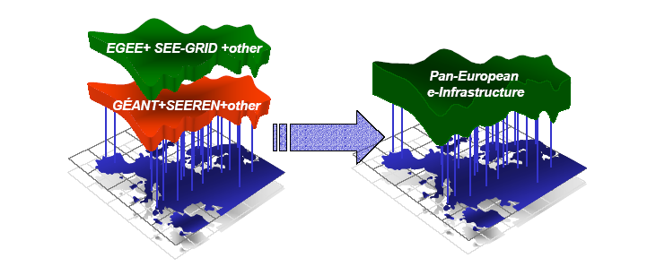

Figure 1. Unification of networks and middleware into a common e-Infrastructure
(Hellas Grid Task Force, 2003)

Such a unification can be accomplished in a very large scale with a very fine grain since everybody can participate in a grid system. Participants can be personal computers with their modern capabilities, parallel computing systems known as computer clusters or large-scale computing centres like distributed memory clusters or symmetric multiprocessing systems (SMPs).

3 Greece and the Grid

3.1 Grid movement in Greece
The greek academic community and the industry have realised the changes that computer science is going through as far as grid technologies are concerned. For that reason, a scientific committee has been established with the name Hellas Grid Task Force. On the 17th of November, 2003 this committee has published a strategic text that outlines the importance of grid systems internationally, how grid systems will affect Greek reality and how grid systems can be implemented in order to reach a national Greek grid (Hellas Grid Task Force, 2003). The grid movement in Greece is motivated by the many years of experience that the greek academic community has in leading edge distributed technologies and thanks to the successful operation of the national research and educational network GRNET. Another propitious coincidence is the successful progress of the European network GEANT and the potential of the Pan-European network into which Greece wants to have an active role. The leader of the grid movement in Greece is Hellas Grid Task Force with the help of the ministry of Economy and the ministry of Development. Active participants of the grid movement are almost all the Universities in Greece that are concerned about computer sciences and a lot of governmental and industrial organisations. The University of Macedonia is also a partner of the Hellas Grid Task Force, having as representative the corresponding client of this project, Prof. K.G. Margaritis. The situation in Greece is still in a quite premature phase but a lot of effort is being made in order to reach a national grid. The firsts steps planned are to create a prototype system that will interconnect various academic organisations spread in Greece in order to form a national grid for experimental applications (e.g. weather forecasting). The participant nodes of this project and the existing network infrastructure can be seen in the following figure.
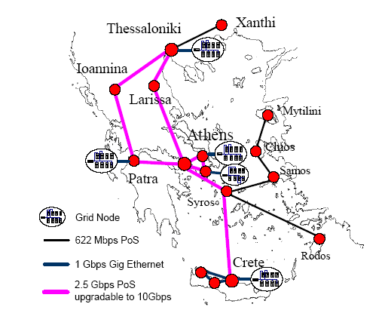

Figure 2. Node distribution and interconnection in the first stage of the HellasGrid.
(Hellas Grid Task Force, 2003)

3.2 Difficulties for establishing a national greek Grid
Beside the active movement that is taking place in Greece towards the new emerging grid technologies, there are certain difficulties that retard the achievement of a national Greek Grid. Despite the fact that computer networks are emerging rapidly and are getting in every greek house, high-speed broadband connections are until now only available for academic and research institutions. The morphology of the country does not allow fast internet connections to reach discontiguous areas. Furthermore, different computing infrastructures are distributed in the various organisations. In this distribution, despite the geographical difference, each organisation is working under its own rules and practices. In order to accomplish a unification which is the primary goal of the grid movement, all of these organisations must come to maturity and realise the collaborative character that grid technologies demand. Finally, another difficulty is that Greece is a small market for grid services. So, in places outside of academic institutions the demand is very limited for such technologies. Most of the companies in Greece do not have those departments that could present a potential scenario of grid services usage for the needs of their company. So, an insufficiency is observed in the technological progress of modern companies due to the limited needs of the indigenous market (Hellas Grid Task Force, 2003).

3.3 Grid prospect in Greece
The grid prospect in Greece having as leading body the Hellas Grid Task Force can be fulfilled after making some certain steps. First of all, constant economical help must be provided by the government and the competent ministries. Second, the scientific, academic and research community in Greece must be continuously active in the emerging grid technologies by taking advantage of new technologies and presenting prototype grid applications. This will lead to a solid scientific ground onto which all research communities can be based in order to achieve a good level of familiarity with the grid technologies and services. The know-how of the scientific community should reach the levels of expertise that it has reached for the Web technologies and services. Furthermore, the interconnection of various institutions is going to be as easy as it is for on-line interconnection through the Internet and the World Wide Web (WWW). The field of Grid systems will be in the next years the new Internet. It will be the highway not only for information but for knowledge and services too, the new medium through which e-services will be provided for the sciences, the economy and the Public Administration.
In order to reach that point small and careful steps must be taken. Central infrastructure and some basic services, like authorisation and authentication, must be developed through the HellasGrid project. Development of prototype applications for e-Science and e-government will bring out good practices. Creation of analytical guides for creating and using grid services will give a head start for the non experts. Promotion of secure services having to do with e-government and e-health will present the capabilities of grid systems to the public and will gain their acceptance. Finally, the official organisation that will have the responsibility of creating, maintaining and distributing grid applications will be the equivalent to what exists today as the electrical power grid organisation. Of course, all these may seem vary distant for now but by applying some certain practices it can be feasible. First of all, academic, scientific and industrial organisations can create internal IntraGrids that will have as aim the better utilisation of their resources. Later, many IntraGrids can be connected to each other to form ExtraGrids which can finally take the form of a single national grid. The final ambition is to create InterGrids with the absolute target of the World Wide Grid (WWG). This term refers to a society where different organisations can be connected internationally and work collaboratively by exchanging information and services (Hellas Grid Task Force, 2003). Although this may sound very futuristic, existing knowledge and infrastructure worldwide can form the basis for a WWG.

4 Architectures

4.1 Various distributed architectures for the Grid
Grid systems can be split in three categories; computational grids, data grids and service grids (Hellas Grid Task Force, 2003). The aim of this project is to create a computational grid. That is, a system that will allow the participation of any member of a VO in a computational problem that is high demanding in computing and storage resources. A client of the VO will be able to submit a heavy job which will then be split in multiple smaller tasks and each one of these tasks will in turn be executed by the participants. In order to create such a computational grid many distributed approaches must be taken under consideration. Some of these are the Single Program Multiple Data (SPMD), Data Pipelining, Divide and Conquer and Master-Worker (Silva and Buyya, 1999). In the SPMD approach every participant is executing a single program but on a different slice of data. Each task is characterised by the data over which the common code is executed (Quinn, 1994). For these kinds of systems the single program is initially transmitted to all the participants, and the data slice is requested before each execution. It can be characterised as a quite simple thus restrictive approach. The data pipelining approach refers to putting the right data in the right place in the right time in order to reduce communication overhead (Zhu and Hendren, 1999). In this approach extra complexity is added by the fact that data movement must be foreseen by using statistical data. The Divide and Conquer technique refers to the recursive division of a large task into two smaller tasks until the grain of a single task satisfies some certain criteria specific for a system (Tiskin, 2001). Again in this approach the definition of the correct grain depends on statistical data and the specific characteristics of the environment under consideration, something that makes the algorithm quite complex. In the Master-Worker model a master is receiving a large task from a client and splits it in several smaller tasks. These smaller tasks are afterwards assigned to multiple workers for execution. The master is gathering the results from the workers and when the computation has completed and he has gathered all the results, he merges them to form the final result which is then returned to the client (Heymann et al, 2004). After careful discussion with the client of this project we have decide that the simple SPMD architecture may not be sufficient. The Master-Worker approach was deemed to be more suitable for the system that we wanted to create. One requirement was that the user should be able to define the grain of the task and the location of the data without having to use complex algorithms like Divide and Conquer and data pipelining. That is why we have decided for this system to be designed based on the Master-Worker paradigm.

4.2 The simple Master-Worker design pattern
It can be said that the first system that was using the Master-Worker paradigm in a large scale was the SETI@home project by NASA (George and Scott, 2002). In this project the users had to download and install a client application in their desktop PCs. Actually, this application was a screen saver that was activated when they left their computers idle. Each time that they were connected to the Internet they fetched some data to work on or they returned the results that they have produced. This system gave the opportunity to anyone that had a non-permanent connection to the Internet to become a worker for the SETI@home project. The number of workers could increase or decrease unpredictably. This is the basic structure and environment of a Master-Worker system. The master is receiving a large job from a client and it slices it in multiple subtasks. Each one of these tasks is then retrieved by a worker which executes the subtask and returns the result. The master gathers all the results and produces the final result which is returned to the client (Heymann et al, 2001). Of course, more sophisticated forms of the Master-Worker paradigm exist such as NetSolve (Casanova et al, 1999), Nimrod (Abramson et al, 1995), AppLeS (Shao et al, 1998) and MW (Goux et al, 2000; Buaklee et al, 2002). These systems use more sophisticated technologies like adaptive scheduling. Questions like how many workers should be allocated for a given job and how should tasks be assigned to the workers must be answered for adaptive scheduling to be implemented (Heymann et al, 2004). It has been agreed with the client that for the needs of this prototype system, adaptive scheduling will not be implemented and it can be added as an extension in the future. For this system, each worker that is participating in the computation is assigned one task at a time, executes it, returns the result and gets another one until all tasks have been executed. It must be stated though that adaptive scheduling can improve significantly the efficiency of the system especially for the University network that the system will operate in, which is described as a dedicated cluster for the system. Heymann et al state (2004) that adaptive scheduling in dedicated clusters can improve the efficiency of the system more than it would benefit a system in a non-dedicated cluster. This prototype system is targeting for a wider network in its final form. Wider networks tend to behave more like non-dedicated clusters. That is the reason why no effort was paid for adaptive scheduling since it might be useless in the future.

4.3 Fallacies of the simple Master-Worker design pattern
The simple Master-Worker design pattern loses a lot in efficiency because of its simplicity. The tasks that are transmitted from the master to the workers contain both the code that will be executed and the data that the worker will work on. This means that every time that the worker will take the task from the master he will get both the code to execute and the data. But what happens in the case where the code for execution is always the same as for SPMD systems. In this case the worker will repeatedly take the same code each time that he takes a task. Moreover, there are certain situations that even all the data have to be transmitted for a task to be executed. There are certain algorithms where the returned result is not depended on the code nor the data but on other parameters. In situations like these the same code and data are transmitted repeatedly from the master to the workers. Of course, in cases where the size of code and data are not large (let us say less than 10KB) the communication overhead is not very large although the system is quite poor from a design perspective. For example, the initial testbed of this system was a master that was generating multiplication tasks of two numbers. In this situation the code to be executed and data to work on were very small. The data were two floating point numbers a and b and the code to be executed by the worker had the form:

result = a * b;

But what happens in the case of the ray-tracing algorithm that needs to be implemented as a final test-bed for the system. The ray-tracing algorithm falls in the category where all the code and the data are needed for a task to be executed by a worker. The various results are differentiated by the area of the final image that the worker will work on. The code that is needed to produce a ray-traced image can be from a few kilobytes to many megabytes depending on how sophisticated the algorithm is (if it supports reflections, refractions, shadows, textures etc.). Furthermore, the data that a worker will work on are always the whole three dimensional scene. Again the size of the scene can be from a few kilobytes to many megabytes (depending on the number of objects it contains, the complexity of the objects, the size of the textures etc.). It is obvious that for that case, transmitting the whole code and all the data every time into a requested task can lead to repeated transmission of many megabytes of data. Of course, it is obvious that communication overhead in this case is very large and easily observable.

4.4 Enhanced Master-Worker design pattern
So, there had to be a way to avoid repeated transmission of the same data due to communication overhead problems. The solution came with the use of global IDs for codes and data and replication of them locally in the worker. Tasks would not be the only transmitted objects in the system but codes and data too. The tasks that were generated by the master did not have in them the code and data anymore, but the IDs to the code and data that this task refers to. Every time that a worker is receiving a task from the master he checks to see of he has the code with ID the same codeID that the task has. If not it requests it and receives it from the master and he stores it locally. If not he uses the code that he has locally stored without any further communication with the master. The same thing happens with the data too. If the data that he has locally stored are not the same with the data that the received task needs, he takes them from the master, else he works on the local ones. This technique works very well in the case of the ray-tracing algorithm. This happens because only one code and one piece of data are needed globally for the tasks to be executed. Thus, the workers will take the code and the data only once when they take their first task and they will never take them again. Imagine the code to be thirty megabytes and the three-dimensional scene to be half a gigabyte. It is obvious that the benefit in this case is very large.
Despite the fact that the system was quite more efficient after the application of the above technique, it can be furthermore enhanced. The problem now is that the replication of data that happens in the workers is only for one code and one piece of data. Replication can be extended and be more sophisticated by using a buffer in the workers that will stop putting codes and data in it after a certain number of items or a maximum size. This strategy would benefit situations where recently used data and codes are needed again.
Nevertheless, the technique applied has enhanced the simple Master-Worker design pattern in a way that it is easily extensible with replication strategies suitable for the needs of various systems.

5 Frameworks
One of the requirements of the client was that the system would be open-source and platform, operating system and hardware independent. That is the reason why the programming language that was used was Java from the first place. There are many frameworks for Java that can be used for the implementation of this prototype Master-Worker system. Due to time limitations, research was restricted to three of the most well-known and widely used frameworks for building distributed applications with Java; the Remote Method Invocation (RMI) framework, Jini and Jxta.

5.1 RMI, Jini and Jxta overview
RMI implements a synchronous blocking Remote Procedure Call (RPC) mechanism that supports dynamic classloading capabilities. RMI uses two extra classes to make remote service communication possible. These are called stubs and skeletons. The stub object will be transported to the client in order to communicate with the server process remotely. In a general RMI setting, stubs are delivered to clients when they query the RMI registry. The network location of the registry is known to all clients as is the binding name under which the stub is registered (Vanmechelen, 2003). It can be said that RMI provides the basic functionality for the implementation of this prototype system. It provides the capability of remote processes to exchange objects. These objects can encapsulate code (the code that workers will execute) and data (the data for the computation and the results). But the purpose of this project was not to build just a Master-Worker system. It was the development of a grid enabled platform that would provide computational power. RMI was not created for grid environments. It just describes a set of protocols and rules for invocation of methods of remote objects. This approach does not fit well into a grid environment as mentioned earlier in Foster et al (2002). Grid systems cannot be defined by long and complex protocols but they should be defined in a more service-oriented manner. This was the basic inefficiency of RMI and the major reason that it was abandoned very early. On the other hand, a service-oriented approach is taken by Jini and Jxta which was the reason why they were investigated in more depth and they were the remaining candidates for the implementation of this system.
Jini is a network technology extension to the Java programming language. Jini provides for the automatic discovery of services on the network using a set of simple lookup and discovery protocols. These protocols are designed to enable the building of scalable and robust networked systems. Jini leverages the dynamic remote class loading ability of Java to deliver services, or proxies for these services, to clients (George and Scott, 2002). One of the fundamentals of Jini is the Lookup service, which is at the core of how clients and services interact. The Lookup services act as dynamic yellow pages. Services register a proxy object with the Lookup services, as well a set of attributes that gives more detail about the services. Proxies can be self contained or communicate with a remote service using any wire protocol it requires. These service objects support well known interfaces, so a client finds a particular service that it needs by sending a template to the Lookup service, specifying in the template which classes, interfaces, or attributes the required service must match (George and Scott, 2002).
JXTA framework is used to create a common platform that makes it simple and easy to build a wide range of distributed services and applications in which every device is addressable as a peer, and where peers can bridge from one domain into another (Sun Microsystems Inc., 2001). JXTA technology leverages open standards like XML and Java technology that include the ability for shells to connect commands together using pipes to accomplish complex tasks. It builds up from a set of basic functions to support P2P applications. JXTA technology comprises a set of protocols. Each protocol is defined by one or more messages exchanged among participants of the protocol. Each message has a pre-defined format, and may include various data fields. These protocols are defined to be independent of programming languages (can be implemented in C/C++, Java, Perl, etc.) and transport protocols (TCP/IP, HTTP, Bluetooth, etc.). The JXTA technology protocols standardize the manner in which peers discover each other, self-organize into peer groups, advertise and discover network resources, communicate with each other and monitor each other (Sodhy et al, 2003).

5.2 Jini advantages and disadvantages

5.2.1 Jini advantages
Jini does not prescribe a particular communication protocol for communication between proxy and service. Although RMI fits well into the communication mechanism of the framework, other communication protocols can be used. Jini provides an abstraction layer for the communication mechanism which can be implemented in many ways without affecting the clients. This capability influences positively the overall image of Jini in conjunction with the criticism that RMI has received for its performance (Breg, 2001). Furthermore, Jini has a leasing system that contributes to the system robustness in cases of system crashes or network failures. In addition, it uses a search mechanism based on templates which extends the object-oriented paradigm very naturally for network applications (Vanmechelen, 2003). Clients can create templates of services they want to find and restrict the results by setting attributes to the templates. Also, Jini totally abstracts the devices that participate in a network. This gives the capability of legacy systems, even not written in Java, to participate in the network. Moreover, it has a transaction mechanism abstracted in interfaces that describe a two phase commit (2PC) protocol which can be tailored for the needs of certain applications. It also supports remote events with policies that can be defined by the implementer in depth. Jini also provides the capability of service proxy updates in case of newer versions. Generally, the Jini framework can be characterised as simple since it minimises interaction with lower level API for discovering, creating and publishing new services (Vanmechelen, 2003).

5.2.2 Jini disadvantages
The first disadvantage of Jini is that it is dependent on the Java programming language. This means that legacy systems that are not written in Java need an additional effort in order to participate in a Jini network, which is the provision of event handling mechanism, lease and discovery services. Of course, the advantages of Java overlay significantly this disadvantage; and these are the transferable code and dynamic class loading. Another disadvantage of Jini is that although it does not mandate full use of RMI, its use is obligatory in certain cases like the event and the transaction model. The biggest disadvantages of Jini have to do with the security and the firewall support. The version 1.2.1 of Jini that was used for this system does not provide any security mechanism except from that of the Java Virtual Machine (JVM) and the use of policy files. Furthermore, support of crossing the boundaries of firewalls is totally dependent on the underlying communication mechanism. Of course, RMI cannot cross firewalls, but any implementation of the communication protocol that will be able to do that, will give the same ability to the Jini framework too (Vanmechelen, 2003).

5.3 Jxta advantages and disadvantages

5.3.1 Jxta advantages
The biggest advantage of Jxta is that it is truly platform independent, since Jxta protocols are XML based. Jxta is also totally communication protocol independent. The endpoint abstraction, combined with a uniform peer addressing scheme, makes the platform’s virtual network, protocol agnostic (Vanmechelen, 2003). The peer-to-peer (P2P) nature of the framework provides a common platform for P2P application developers, freeing them from basic concepts of such systems and providing a common ground for P2P applications integration and interoperability. Furthermore, this P2P nature makes the framework totally distributed, free of centralized concepts. Every peer is equal and every peer can create a new community. To be more specific, some peers can have a different role, that of relay or rendezvous peers. The use of these kinds of peers creates a virtual network that can cross firewalls and NATs. Thus, Jxta is not limited by these networks barriers and this is one of its big advantages with respect to grid systems and the vision of the World Wide Grid (WWG) (Vanmechelen, 2003).

5.3.2 Jxta disadvantages
The flexibility that Jxta provides because of its generality through its P2P orientation adds some cost in terms of clarity. Use of XML based protocols and virtual network support make the system very interoperable and technology independent but a lot of effort needs to be made in order for a system based on Jxta to be implemented. Furthermore, the Jxta framework is still in flux. There are not enough maturity or success stories, something that makes the use of it very dangerous. In addition, the discovery semantics are not interface oriented. Services are identified by the static value of one of their attributes. Also, the generality of the framework implies the absence of a programming model on which interacting peers can rely to invoke each other’s services. Finally, another consequence of the immaturity of Jxta is the lack of full documentation for the framework something that makes the use of it extremely difficult (Vanmechelen, 2003).

5.4 Selection of framework
The comparison of the two frameworks will be based on the eight fallacies of distributed computing as first advocated by Peter Deutsch (Vanmechelen, 2003). These include the following eight false assumptions:
1. The network is reliable
2. Latency is zero
3. Bandwidth is infinite
4. The network is secure
5. Topology doesn’t change
6. There is one administrator
7. Transport cost is zero
8. The network is homogeneous
With regard to how they cope with these fallacies, the two frameworks are going to be evaluated. Finally, the certain intricacies of the system under consideration are going to put the final mark for the selection of the most suitable framework.

5.4.1 Comparison of Jini and Jxta
As far as network reliability is concerned, Jini provides distributed transactions for cases of partial failures, the smart proxy which redirects for services to other implementations of the same service in case the primary service is unreachable, remote exceptions that expose the remoteness of services, a discovery mechanism that enables developers to leverage service robustness by adding more service instances to the network in a flexible way and an event model that takes care of missed events with the use of sequence numbers. On the other hand, Jxta distributes service queries in a more wide scale thus leveraging the robustness of collaborative services. Furthermore, Jxta’s discovery mechanism has minimal central dependencies, making services more easily reachable, and the ability to reroute requests in cases of broken routing links more robust. Finally, as in Jini networks, discovery mechanism enables developers to leverage service robustness by adding more service instances to the network in a flexible way. In conclusion, JXTA provides measures on the network connectivity level while Jini provides higher level concepts to deal with the reliability of the underlying network (Vanmechelen, 2003).
For the fallacies that bandwidth is infinite and the transport cost is zero, Jini provides an event model with the delivery cost in mind. In addition, it supports the use of certain policies for leasing and distributed transactions. JXTA addresses this fallacy conceptually by envisaging a networked community that responds to service requests in a collaborative way (Vanmechelen, 2003). This means that Jxta is relying on the good will of the various peers, since no central control exists and the whole system operates in a P2P manner. Of course this many times leads to what is known as the tragedy of the commons (Hardin 1968).
As far as network security is concerned, Jini as mentioned earlier does not provide any mechanisms while Jxta has an enhanced security infrastructure using TLS pipe transports and unique peer IDs.
For the case of volatile topology both frameworks address this issue with the use of a dynamic discovery mechanism. Clients do not know where the services are located in the network but they can reach them and use them.
Furthermore, the single administrator problem is addressed by Jini with the use of a leasing mechanism. Although this does not exterminates the need of administrators, it makes their life easier. Jxta also uses the notion of lease but in a more non-deterministic fashion. Although services have a certain lifetime it is responsibility of the client to check their availability (Vanmechelen, 2003).
Jini addresses heterogeneity with the different communication protocols that it can use. However it is still dependent on IP addresses since it does not take under consideration non-Java clients. On the other hand, the support for heterogeneous networks is the key goal of Jxta. The XML based protocols and the transparent use of relay peers make a Jxta network very capable in cases of heterogeneity and network boundaries (like firewalls etc.) (Vanmechelen, 2003).
In general, both frameworks have their certain strengths and weaknesses. They clearly have a different scope and in many cases they can be complementary. For the needs of this project it was decided that the Jini framework will be used. Its dependence on Java is not a problem since that was a requirement of the client from the first place. We decided to avoid the complexity of Jxta since its biggest achievements were not directly desired in this project. The network connectivity capability was not desired in such a wide scale as advertised by Jxta. After careful discussion with my client I concluded that this system was targeting trusted Wide Area Networks (WANs) and not the Internet. Furthermore, for the same reason, security issues needed not to be resolved in depth, and the security mechanism of the JVM was sufficient. In addition, the nature of a Master-Worker system is by its nature a system with central management (the master). So, the extra complexity added by the P2P fashion of Jxta was not only undesirable but a practice to avoid too. Finally, as far as security is concerned, it has been stated that the version 2.0 of Jini will have a very capable security mechanism so security issues will disappear for Jini too (see Jini homepage).

5.4.2 Jini/JavaSpaces
Another big reason that Jini was used for this system is the positive comments that it is getting by the present literature for its suitability for Master-Worker systems in conjunction with a virtual shared memory service that it provides called JavaSpaces (Suzumura et al, 2001; Ledru, 1998; Sheil, 2003; George and Scott, 2002). JavaSpaces is a service coming with the Jini distribution and it is based on Gelernter’s TupleSpaces for Linda (Gelernter, 1984, 1985). It is a virtual shared memory that can be accessed by any computer that has access to the Jini network (Sheil, 2003). A JavaSpace will register in the Jini network using the Lookup service so that other participants can find it too. Items in a JavaSpace are Entry objects, which are serialised Java objects. They can be found with the use of templates as described earlier in the same way that the Lookup is accepting service requests. The basic API of the JavaSpaces service consists of three methods: read, write and take. Take reads an entry and deletes it from the JavaSpace. There are versions of read and take that are executed only if the object that is being searched using a certain template exists, otherwise they return null. In the usual case, when the client requests an entry that does not exist, he will be waiting until his search attributes are satisfied and his request returned and entry. At that point a notification mechanism will send the result to the client. The transaction mechanism can be used for entry requests to be encapsulated in transactions with limited time. Also the lease mechanism for Jini can be used for restricted access to the service. Generally, JavaSpaces in combination with the Jini facilities for leases, transactions, and remote events, provide
a simple yet powerful distributed programming environment that can be used for the implementation of this prototype Master-Worker system (George and Scott, 2002).

5.5 System operational overview
So it was decided that this system will be a virtual shared memory system which will be accessible by the master and the workers. No direct communication between the master and the workers will take place and all communication will happen by using the shared memory, which in this case will be the JavaSpace service. This way the master and the workers are loosely coupled (Freeman, 2000). They do not depend on each other; they just need to have access to the virtual shared memory. The operational overview of the system can be seen in the following figure.
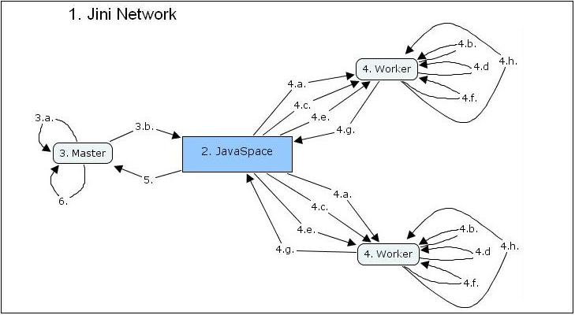

Figure 3. System operational overview.

- Start up Jini network
- Start JavaSpace service
- Start Master
  - Master generates tasks, codes and data
  - Writes them to JavaSpace
- Start Worker(s)
  - Worker takes task (if exists) from JavaSpace
  - Looks if it has the code with the ID that the task requires
  - If not it retrieves it from the JavaSpace
  - Looks if it has the data with the ID that the task requires
  - If not it retrieves them from the JavaSpace
  - Executes the task
  - Writes result to JavaSpace
  - Returns to 4.a.
- Master collects results from JavaSpace
- Master transforms collected results in order to form final result.

In order to start the Jini network you must first start an http server for the transmission of code. Jini has a built in simple http server that can be used. Then, the RMI activation daemon must be started (the rmid tool). Continuing, the Lookup service must be started in order for participants to find the various services. The next step is to start the JavaSpace service and the transaction manager service. When the Jini network has been set up, the master and worker processes can be started. After they have resolved the JavaSpace service which is up and running they can read and write entries from and to the JavaSpace. First, the master generates the task, code and data objects and writes them to the JavaSpace. The workers in turn take tasks from the JavaSpace and, if needed, codes and data too (see section 4.4 “Enhanced Master-Worker design pattern”). Afterwards they execute the task, write the result back to the JavaSpace and take another task if there exists one. The master gradually gathers the partial results and when all the results have been collected, he merges them to form the final result which is returned to the client.

6 Implementation

6.1 Initial design
The first steps made for the implementation of the system were taken from two articles of the JavaWorld online magazine (Freeman, 2000; Hupfer, 2000). These two articles explain how one can create a compute server using Jini and JavaSpaces and continue by enhancing it with a transaction manager in order to be more robust. The basic entities of this design are the master, the worker, the task and the result. Another entity is added after the enhancement of the system with a transaction manager. In this design, both the master and the worker have a reference to a JavaSpace object to which they talk in order to exchange tasks and results. Furthermore, the master has the responsibilities of generating tasks and collecting results. The class diagram of the initial design can be seen in the following figure.
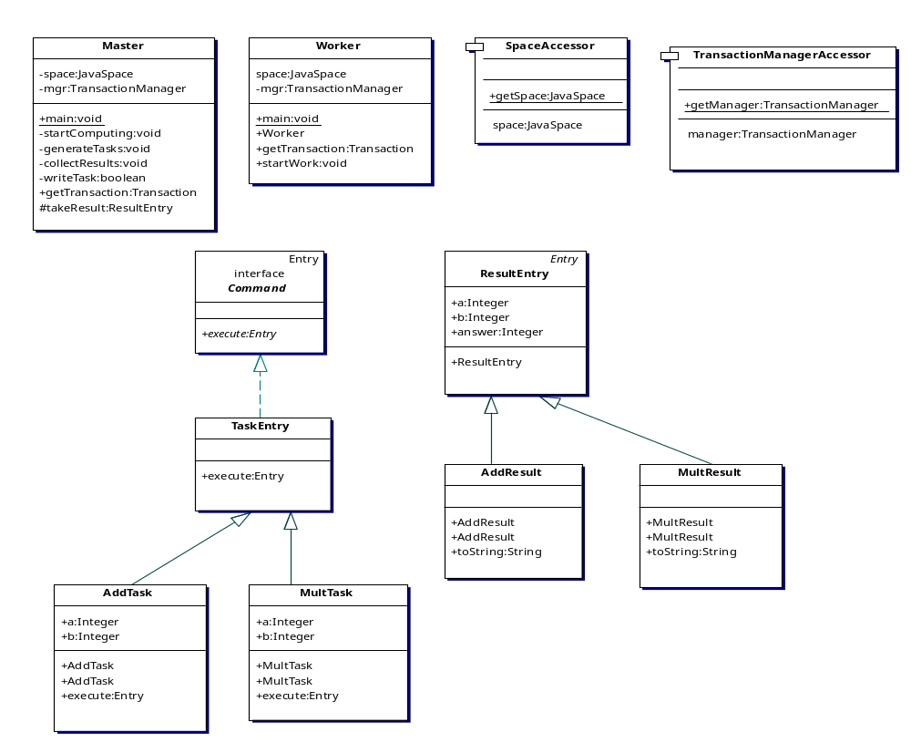
Figure 4. Initial class diagram.

This design is very poor in software engineering terms. First of all, the Single Responsibility Principle (SRP) is violated in the Master class (Martin et al, 2003). The master has two responsibilities, that of generating tasks and collecting results, which can change along a different axis. Furthermore, the Master and Worker classes can only talk to a JavaSpace object, having an absolute reference to that class. So, violation of the Dependency Inversion Principle (DIP) is observed (Martin et al, 2003). It can be said that the only good thing in this design was the use of the “Command” design pattern in the Task class (Martin et al, 2003).

6.2 Object oriented design principles and patterns applied
First of all, the SRP was applied to the Master class. This can be seen in the following figure.
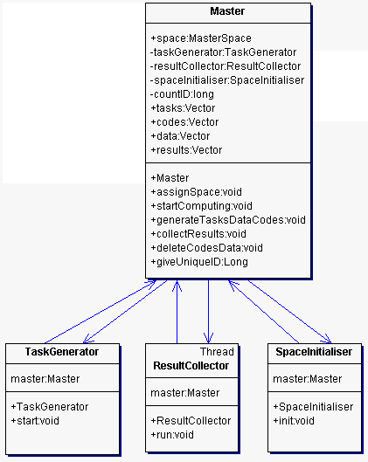
Figure 5. The Master after application of the SRP.

It can be seen that the master has distributed his responsibilities to three other classes. The TaskGenerator has the responsibility of writing tasks to the data space. The ResultCollector has the responsibility of collecting results from the space. This class has been modelled as a thread because the collection of results can take a lot of time waiting for the workers to execute the tasks and write the result; so there was not any reason for this procedure to halt the whole master process. Finally, the SpaceInitialiser class has the responsibility of clearing the data space from the codes and data that were in there and were used by the workers, bringing it to its initial state.
Furthermore, the Master and Worker classes do not depend anymore to a JavaSpace object. They have references to the MasterSpace and WorkerSpace interfaces respectively. These interfaces are then implemented by the DataSpace abstract class which unifies the two interfaces.

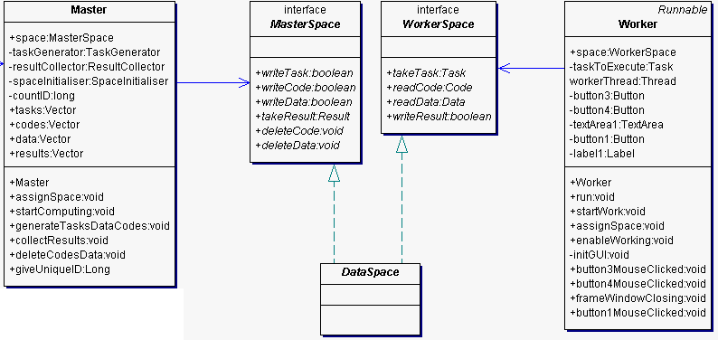

Figure 6. The DataSpace class after application of the DIP.

The reason for using two interfaces was due to the Interface Segregation Principle (ISP) (Martin et al, 2003). The unification of them under the DataSpace abstract class was because the implementation provided for the two interfaces should be in some way compatible. For example, there is not any meaning in providing a MasterSpace implementation that will communicate with a JavaSpace service and a WorkerSpace implementation that will communicate with a DBMS. That is why the required implementation is that of the DataSpace class and not that of the two interfaces.
Finally, the task, code and data classes do not anymore depend on the Entry interface as needed by the JavaSpace technology. They are simple classes that can be furthermore extended to create any kind of tasks, codes and data. In this case the design was made in such a way, so that conformance to the Open Closed Principle (OCP) to be as feasible as possible (Martin et al, 2003).
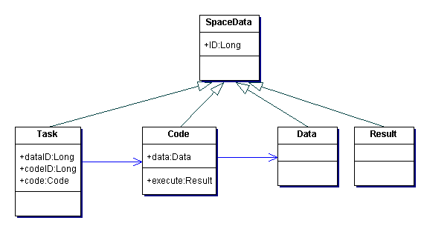
Figure 7. The structure of the space data.

In this diagram, the technique described earlier can be seen. The Task class references the Code and Data objects through the use of the dataID and codeID attributes. In addition, it is stated that the use of the “Command” pattern has been preserved for the initial design inside the Code class which has the responsibility of executing the code.

6.3 Revised design
So, in the final stage, the revised design consists of four packages.
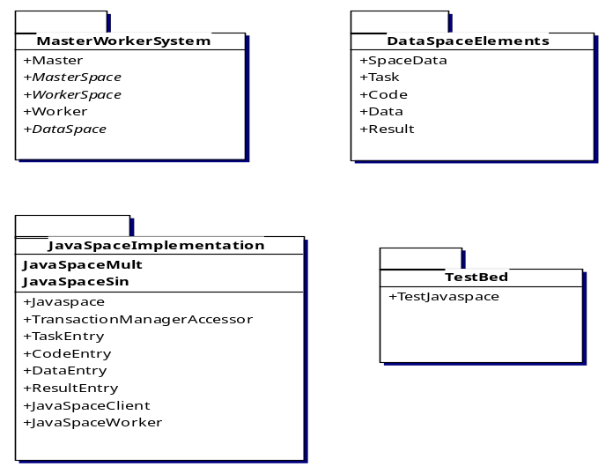
Figure 8. Packaged System

The MasterWorkerSystem package contains the basic classes that form the structure of the system in its generic form.
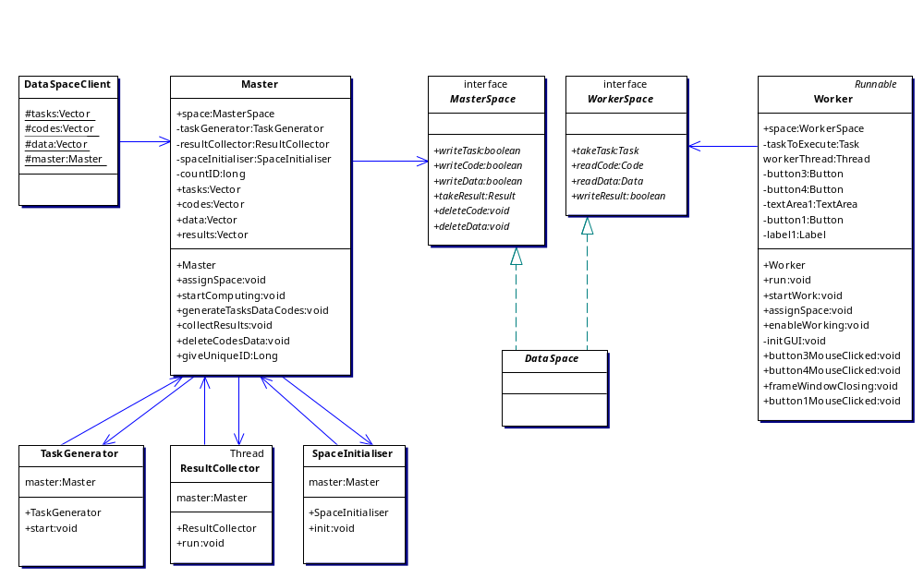

Figure 9. The MasterWorkerSystem package.

It contains the Master classes with its helper classes, the Worker class, the two interfaces and the generic abstract class DataSpace.
The DataSpaceElements package contains the classes that describe the generic form of the task, the code, the data and the result that this system understands. This package can be seen in figure 7.
The JavaSpaceImplementation package contains the implementations and the extensions of all those classes that are needed for this system to work using Jini and JavaSpaces.
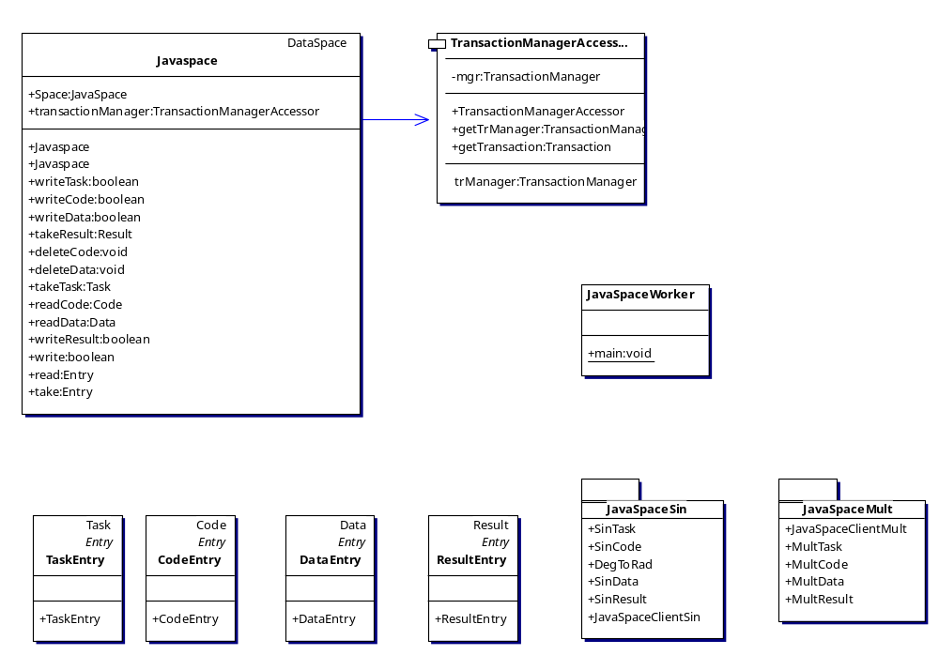

Figure 10. The JavaSpaceImplementation package.

The Javaspace class extends the DataSpace abstract class and provides implementation of all the methods of the MasterSpace and WorkerSpace interfaces. This class also uses a TransactionManagerAccessor class that is used for taking advantage of the transaction manager service provided by JavaSpaces. This package also contains client packages for using the system in calculations of multiplications of numbers and calculation of the sin of angles. Finally, it has the JavaSpaceWorker class which starts a worker that uses the JavaSpace service. Generally, this package is the full implementation of the system using JavaSpaces. The JavaSpaceSin package extends the entry objects of the JavaSpaceImplementation package in order to be used for the calculation of the sin of angles. The JavaSpaceClientSin class extends the DataSpaceClient class from the MasterWorkerSystem package. This class has the responsibility of feeding the master with tasks, codes and data and sending messages for starting the calculations and the collection of the results.
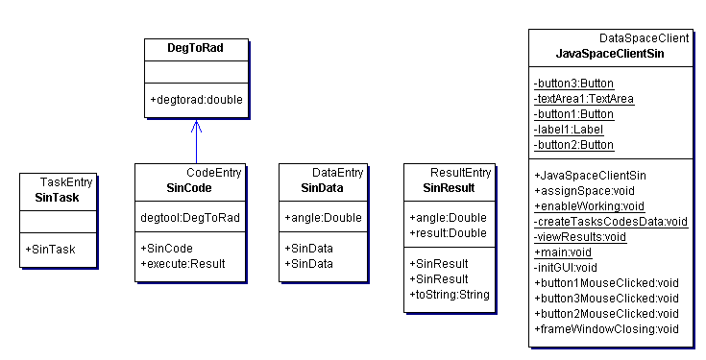

Figure 11. The JavaSpaceSin package.

The same set of classes is contained in the JavaSpaceMult package for multiplying two numbers. These packages were used in the initial phase of the project as simple tests before implementing the ray-tracing algorithm.
Finally, the last package contained in this system is the TestBed package which will hold in the future all the test cases for the various implementations of this Master-Worker system.

6.4 Advantages of the revised design
After the application of the object oriented design principles and patterns and the various other techniques, the system has become more sophisticated in Software Engineering terms. The biggest breakthrough that this system provides compared to the initial design is that the direction of the dependency has been inverted for the Master and the Worker classes. Both of these classes and the Javaspace class now depend on abstractions, the DataSpace abstract class and the two interfaces. This gives the opportunity for other programmers to provide their own implementations of the DataSpace class. This means that any class that provides implementation of the methods of the two interfaces can be used by the Master and the Worker classes. So, the Jini/JavaSpaces implementation of the system is only one way that the system can operate. For example, in a different implementation the role of the DataSpace can be played by an Object Oriented Database Management System (OODBMS). Oracle 10g has many object oriented and grid extensions. These characteristics of this DBMS make it a very powerful candidate that would fit in the design of this system. So, extensibility is the biggest advantage of this prototype system. Furthermore, the generality of the classes that represent tasks, codes, data and results gives the opportunity to the programmer to create any kind of computational problems that he desires. Finally, the technique applied for the division of the task object to task, code and data has made the system much more efficient in communication issues as it has been discussed earlier.
So, in conclusion, if someone wants to use this system he has the opportunity to use Jini and JavaSpaces but he is not restricted to the use of these technologies since he can provide his own implementation. Once he has decided which implementation to use, he must provide extensions of the task, code, data and result classes which are suitable for the computational problem that he wants to solve. The final class that the programmer has to provide is an extension of the DataSpaceClient class that will feed the master with tasks, codes and data in order for the computational procedure to start.

7 Evaluation of the prototype system
The first parameter according to which this prototype system is going to be evaluated is its extensibility. The system can be extended in two levels. The first level is that of the implementation of the DataSpace class. The implementation provided here with Jini/JavaSpaces is only one way that the system can operate. Other developers can provide other implementations, like using a DBMS (eg. Oracle). A performance comparison with different implementations would give a solution to the system efficiency problem. The important thing is that anyone can provide any kind of implementation as long as he provides a class that implement the MasterSpace and WorkerSpace interfaces. The second level that the system can be extended is that of the different kinds of tasks that the master can distribute and the workers can execute. The set of classes in the DataSpaceElements package can be extended in order to provide classes suitable for different implementations and different tasks. This procedure is quite straightforward given the correct guidelines (see chapter 8 “Raytracer implementation”). The system has been designed in order to be easily extensible and as general as possible.
The selection of the Jini/Javaspaces technologies formed the design of the system in such a way that its central entity is a virtual distributed shared memory, the JavaSpaces. This gave the opportunity for the master and the workers to be loosely coupled. The master needs not to know how many workers are working on a certain task and the workers do not care about what kind of task they execute. All the communication between the master and the workers is being made via the JavaSpace. This loose coupling made the system very easily scalable. Any computer with access to the JavaSpace can become a worker and participate in the computation. This way, the system scales naturally and the computation is accelerated as more workers participate.
As far as the OO design is concerned, it can be said that this was the major parameter that the system has acquired all these characteristics of extensibility and scalability. The major OO design principles and patterns that have been applied made the system scalable and extensible. The Command pattern made the Workers unconcerned about the code they execute. The OCP and the DIP gave life to the DataSpace class that makes the system so extensible. Furthermore, it must be stated that many other OO capabilities have been used like class and interface inheritance, late binding, class casting that were very useful for the implementation of this system.
The selection of the architecture and the framework has been made after careful investigation of the client’s requirements and frequent discussion with him. Chapters four and five present the research that has been made for this selection. The goal was to create a prototype system that would satisfy as many of the client’s needs as possible in the given timeframe; a system that would fit more closely to the given parameters of the working environment of the University of Macedonia and that would be as efficient as possible. According to all these, the selections made were a Master-Worker architecture and Jini/JavaSpaces for framework.
The performance of the system has been tested inside the network of the University of Macedonia. I was given access to three PCs. One Pentium 3 at 800 MHz with 256 MB RAM and Windows XP operating system (OS), one Pentium 3 at 800 MHz with 256 MB RAM and Windows 2000 OS and one Pentium 3 at 800 MHz with 256 MB RAM and Linux OS. The system worked fine and the results can be seen in the following figures.
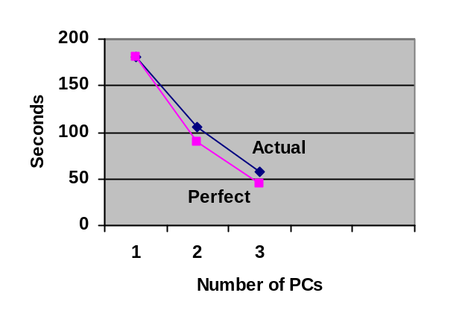
Number  of PCs | Perfect  Speed-up | Actual Computation  Time (secs)
1 | 180.039 | 180.039
2 | 90.0195 | 105.171
3 | 45.00975 | 56.872

Figures 12-13. Test results of the system

It can be seen that almost perfect speed-ups have been accomplished. In one PC the computation lasted 180.039 seconds. In a perfect speed-up the time in two PCs should be 90.0195 seconds and in three PCs 45.00975 seconds. The actual results are satisfactory close to the perfect speed-up values but further testing with more processors would be desirable. The image that was ray-traced contained twenty seven balls and it was using reflections, shadows and a ray-trace depth of ten. The image produced can be seen in the following figure.

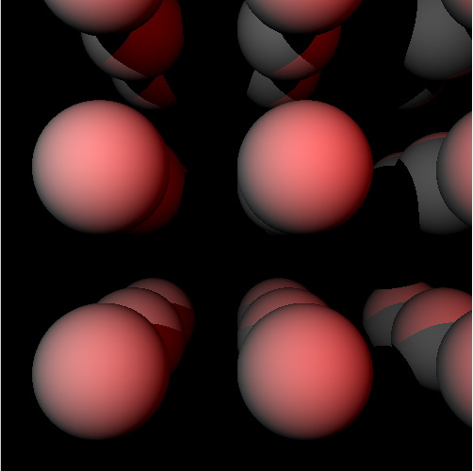

Figure 14. 3D image that was produced for testing purposes.

The client of this project, Prof. Margaritis, expressed his satisfaction for the outcome of this prototype system during the meeting we had where the system was demonstrated. Furthermore, he asked for the source code in order to experiment and explore in depth the capabilities of it.

8 Raytracer implementation
Given the timeframe for this project, it was not feasible for a ray-tracing engine to be implemented from the scratch. That is why it was decided that a third-party raytracer would be integrated into this system in order to operate in a distributed manner as in a Master-Worker system. The raytracer used was an open-source Java raytracing engine from SourceForge, called JRaytracer.
In order for the JRaytracer to operate in this MasterWorker System, I had to provide a set of classes that would extend the JavaSpace data elements and a client class that would feed the master with raytracing tasks, code and data. So, the following package was provided that had all these classes.
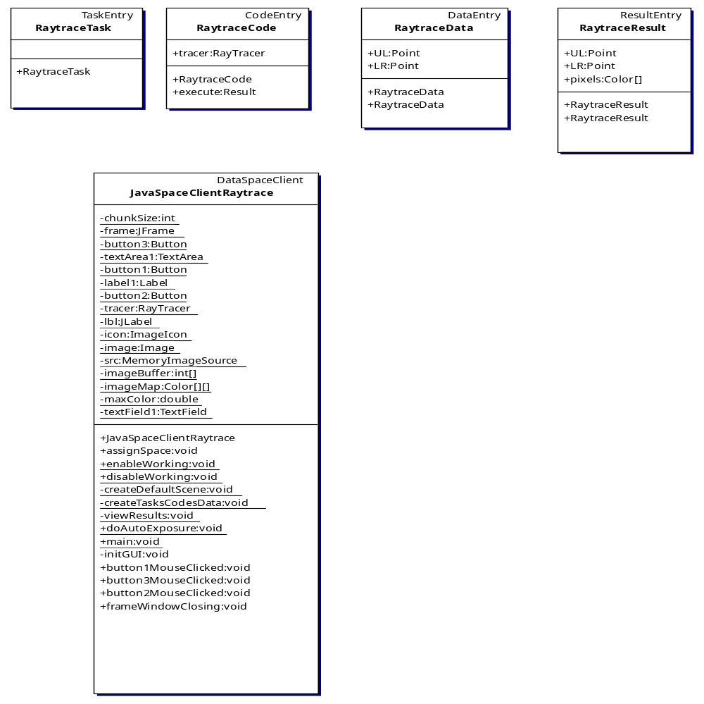
Figure 15. The JavaSpaceRaytrace package.
The RaytraceTask class extends the TaskEntry class from the JavaSpaceImplementation package. The RaytraceCode class extends the CodeEntry class from the same package. This basic attribute of this class is the RayTracer object that was used from the JRaytracer package. This object encapsulates all the code that is needed for the raytracing algorithm to be executed and the three dimensional scene that the raytracer will render. As mentioned earlier, it is the nature of this algorithm that the code and the scene is constant and must be transmitted to all workers only once. The execute() method of this class uses the RayTracer object to render only a segment of the picture that is going to be displayed as a result. The segment of the picture is determined by the RaytraceData class which is the non-constant data element for this computational problem. This class extends the DataEntry class and has as attributes two points; the upper-left and the lower-right position of the segment of the picture. After a worker has received the single code element, it is repeatedly receiving instances of this class which define a picture segment to work on. Then the worker executes the task and writes the result back to the JavaSpace. The RaytraceResult class extends the ResultEntry class. It has as attributes the two point which define the segment of the picture that it contains. Furthermore, it holds an array of colours which is the colour of the individual pixel of the picture. The JavaSpaceClientRaytrace class is responsible for feeding the master with tasks codes and data and receiving results. Furthermore, it deals with the GUI appearance of the master; that is painting the rendered image, defining the size of the segment that the picture will be cut, and for generating the tasks and viewing the results.
As far as the JavaSpace implementation of this raytracer is concerned (and any other implementation of a computational problem in JavaSpaces in general) careful attention must be paid to some certain details. First of all, all Entry objects that are written to the JavaSpaces service must be serialisable by implementing the Serializable interface. They should have an empty constructor and all their attributes should be Java objects and not primitive types (like int, double etc.); they should also be declared public. These are constraints that are introduced by the Jini and JavaSpaces technologies. As far as the implementation of this system is concerned, some further constraints-guidelines are provided. In general, a new package has to be provided for a single computational problem. This package will contain extensions of the JavaSpaceImplementation classes that represent the data elements (TaskEntry, CodeEntry, DataEntry, ResultEntry). The data class should have the data that your problem needs to work on. The result class should have data about the result of the execution of a task and some way to identify itself for which task it provides result. The code class will override the execute() method. This method will provide the code that a task wants to execute. Naturally, it will manipulate the data of the Data object that the Code has reference to. Finally, this method will return a Result object. Careful attention must also be paid to the implementation of the client class which must be also provided with the package. This class must extend the DataSpaceClient class form the MasterWorkerSystem package. The primary responsibility of this class is to create tasks, codes and data objects and feed them to the master. This is done by populating the tasks, codes and data Vectors. At this point it must associate tasks, codes and data. This can be done by using the IDs of the dataspace objects. A useful tool here is the giveUniqueID() method of the master which ensures that no two dataspace objects will have the same ID. It is important to map the correct code and data element to each task in order for the computation to be completed correctly. After that it should send a message to the master for starting the computation. In addition, it should request results from the master and viewing them accordingly.
Some other general remarks for the operation of this system are that the JavaSpace must be emptied from the codes and data that were stored there in order for another computation to begin. This happens because JavaSpaces’ method write() does not override identical entries and this can cause malfunction of the system. Finally, for the raytracer, it is stated that the time for the computation counts immediately before the master starts to generate tasks until the time that it has collected all the results. This happened because it seems to be the fairest way for comparing a raytracer running in a single CPU without having to deal with a foreign DataSpace, with the one that was integrated in this system.

9 Extension to fully operational system
It has been agreed with the client that given the timeframe for this project, the system implemented will be a prototype system that would be easily extendable to a fully operational system, satisfying all his needs. The extensions needed are described in this chapter.
One extension that can be made is that of enabling the master to serve many clients. Currently, once the master has got a batch of tasks it has to be restarted in order to serve another client. This problem can be overcome with the implementation of a more sophisticated ID assignment mechanism. At this stage the tasks are distinguished with a unique ID but they are not distinguished according to the batch job that they belong. This problem can be overcome with the use of multiple JavaSpaces. Furthermore, the master can have a buffer into which batch jobs received by the client can be stored and executed in a first-come-first-served order.
Another extension can be integrated in the implementation of the workers. Currently, the workers can store locally only one code and data object. As it has been stated earlier, in certain computational problems this is not efficient. There may be the need to store more than one code or data objects, depending on their popularity. So, a buffer can be implemented inside the worker class that will store more than one object. The size of this buffer can be determined by the maximum number of elements or by the maximum size of it in bytes.
Another mandatory extension is that of a more sophisticated Graphical User Interface (GUI) for manipulating the master and the workers. It can be seen in the current design that the client and worker classes are polluted by GUI elements. Of course, this is not desirable and has happened temporarily only for the needs of this prototype system. In the full system the programmer can take advantage of the Model-View-Controller (MVC) architecture for integrating GUI components inside these classes (Martin et al, 2003). This architecture decouples the model of the system from the view and the controlling mechanism. So, many different GUIs can be used for the same class, depending on the requirements of each client.
Another mandatory extension is that of a more sophisticated testbed. The testbed provided in this implementation is very poor and cannot satisfy the needs of a serious system. It only contains the testing of some basic methods of this system that was created during the implementation phase. It certainly does not cover all the capabilities of the system so a more complete testbed would be desirable.
It can be seen in the revised design that certain processes of the system have been implemented as threads. This was unavoidable in these cases but no testing has been done for the operation of these threads. The system can be modelled as a finite state machine (FSM) so that it can be investigated in such a way that will assure the avoidance of cases where the threads can produce fault results or the system can get in an inconsistent state (Magee and Kramer, 1999). The current implementation of the threads is quite naïve and has been added at the very late stages of the project as a step guiding towards the final form of the system.
Although the thread modelling is still quite naïve, it gives the capability of starting and stopping the worker processes. In that way, it is very simple for the workers to start working overnight. The worker process can be started at a given time at night and halt at a given time in the morning, continuing again at night. This was presented by the client as a potential usage scenario of the system inside the University of Macedonia network.
Furthermore, it must be stated that give the timeframe, research on the various design principles and patterns suitable for this system could not take place. The expertise on the domain that has been acquired and the general good practices found in the present literature gave as an output the current design and implementation. Anyone if free to criticise this design and propose certain principles or patterns needed for this system to be more mature in software engineering terms. For example, after applying the SRP for the Master class, violation of the DIP happened with the derived classes. Problems like these can be overcome with more careful investigation of the design and extra thought.
After all these, the Prof. Margaritis requested for the clients to submit code via a web page. This is envisaged as a web page where the client can first download the source code with documentation that he can use to write his own code for his computational problem. After he has prepared a set of class files, he can submit them to the master through this web page. The master has the responsibility of notifying the client when will his computation start, and delivering the final output back to the client in the format desired.
The final extension that has been required by the client is a graphical tool for monitoring and manipulating the workload distribution in the cluster. This will first need the implementation of other techniques like parameterised adaptive scheduling. After that and by implementing some certain data communication methods, it is feasible for such a tool to be created. Although this was proposed as a possible extension, my client was satisfied with the stage that the prototype system has reached and the remaining 81 hours were used for documenting the software.

10 Conclusions
The aim of this project was to build a grid enabled system that would distribute tasks to many computers in order for a heavy job to be executed. Research has been done on which architecture and which framework are more appropriate for such a system. Finally, the Master-Worker architecture has been selected and enhanced. In addition, the framework used was Jini 1.2.1 in conjunction with the JavaSpaces. This prototype system has been created in such a way in order to be extensible to a fully operational system. For that, many design principles and techniques have been used. Furthermore, easy scalability has been achieved by loosely coupling the master and the workers. The testing benchmarks have presented very good results in terms of efficiency. At the final stage of the project, a third party raytracer has been modified in order to operate in the system. It is worth saying that less than eight hours were needed for this raytracer to be integrated into this system, something that promotes the extensibility of the system with the best way. The client expressed his satisfaction for the final outcome of this project and we are currently discussing the potential of a PhD or a job inside the University of Macedonia. This project has gone through many stages, always in mind with the best feasible solutions for the design and the implementation given the timeframe of fifteen weeks.

11 References

Abilene Homepage, Can be found at http://abilene.internet2.edu/ Accessed on 07/09/2004.

Abramson, D., Sosic, R., Giddy, J. and Hall, B. (1995) “Nimrod: a tool for performing parameterised simulations using distributed workstations”, Symposium on High Performance Distributed Computing, Virginia, August, 1995.

Bethke, S., Calvetti, M., Hoffmann, H.F., Jacobs, D., Kasemann, M. and Linglin, D. (2001) “Report of the Steering Group of the LHC Computing Review”, CERN/LHCC/2001-2004.

Breg, F. (2001) “Java for High Performance Computing”, PhD thesis, University of Leiden, November 2001.

Buaklee, D., Tracy, G., Vernon, M.K., Wright, S. (2002) “Near-optimal adaptive control of a large grid application”, Proceedings of the 16th Annual ACM International Conference on Supercomputing (ICS 2002), New York, June, 2002.

Casanova, H., Kim, M., Plank, J.S and Dongarra, J. (1999) “Adaptive scheduling for task farming with Grid middleware”, International Journal of Supercomputing, 13(3), pp. 231–240.

Casanova, H. (2002) “Distributed Computing Research Issues in Grid Computing”, ACM SIGACT News Distributed Computing Column 8, pp. 50-70

Czajkowski, K., Foster, I., Kesselman, C., Sanger, V. and Tuecke, S. (2002) “SNAP: A Protocol for Negociating Service Level Agreements and Coordinating Resource Management in Distributed Systems”, Proceedings of the 8th Workshop on Job scheduling Strategies for Parallel Processing.

Foster, I. and Kesselman, C. (1999) “The Grid: Blueprint for a New Computing Infrastructure”, Morgan Kaufmann Publishers, Inc., San Francisco, USA.

Foster, I., Kesselman, C., and Tuecke S. (2001) “The Anatomy of the Grid: Enabling Scalable Virtual Organizations”, International Journal of High Performance Computing Applications, 15(3).

Foster, I., Kesselmen, C., Nick, J. and Tueeke, S. (2002) “The Physiology of the Grid: Open Grid Services Architecture for Distributed Systems Integration”, Global Grid Forum, February 2002. Can be found at http://www.globus.org/research/papers/ogsa.pdf, Accessed on 01/09/2004.

Foster, I. (2002) “The Grid: A New Infrastructure for 21st Century Science”, Physics Today, 55(2), February 2002.

Freeman, E. (2000) “Build a compute server with JavaSpaces”, JavaWorld Jiniolology, January 2000, can be found at http://www.javaworld.com/jw-01-2000/jw-01-jiniology.html, Accessed on 01/09/2004.

GEANT Homepage, Can be found at http://www.dante.net/server/show/nav.007&/ Accessed on 07/09/2004 .

Gelernter, D. (1984) “Linda in context”, Communications of ACM, 32(4), pp. 444-458.

Gelernter, D. (1985) “Generative communication in Linda”, ACM Transactions, 7(1), pp. 80-112.

George, W. and Scott, J. (2002) “Screen Saver Science: Realizing Distributed Parallel Computing with Jini and JavaSpaces“, Parallel Architectures and Compilation Techniques Conference, September 2002.

Goble, C. and De Roure, D. (2002) “The Grid: An Application of the Semantic Web”, SIGMOD Record, 31(4), December 2002.

Goux, J.P., Kulkarni, S., Linderoth, J. and Yoder, M. (2000) “An enabling framework for master–worker applications on the computational grid”, Proceedings of the Ninth IEEE Symposium on High Performance Distributed Computing(HPDC9), August, 2000, pp. 43–50.

GRNET Homepage, Can be found at http://www.grnet.gr/ Accessed on 07/09/2004.

Hardin, G. (1968) “The tragedy of the commons”, Science, 162, pp. 1243–1248.

Hellas Grid Task Force (2003), Strategic Text, Can be found at http://www.hellasgrid.gr/content/downloads/Strategic_Doc_Final.pdf, Accessed on 01/09/2004

Hendler, J. (2001) “Agents and the Semantic Web”, IEEE Intelligent Systems Journal, 16(2), pp. 30-37.

Heymann, E., Senar, M., Luque, E. and Livny M. (2001) “Adaptive Scheduling for Master-Worker Applications on the Computational Grid”, CICYT

Heymann, E., Senar, M., Luque, E. and Livny M. (2004) “Efficient resource management applied to master–worker applications”, Journal of Parallel and Distributed Computing, 64(2004), pp. 767-773.

Hupfer, S. (2000) “Make your compute server robust and scalable with Jini and JavaSpaces”, JavaWorld Jiniolology, June 2000, can be found at http://www.javaworld.com/jw-06-2000/jw-0623-jiniology.html, Accessed on 01/09/2004.

Jini Homepage, Can be found at http://www.jini.org, Accessed on 01/09/2004.

Jxta Homepage, Can be found at http://www.jxta.org, Accessed on 01/09/2004.

Ledru, P. (1998) “Adaptive Parallelism: An Early Experiment with Java Remote Method Invocation”, University of Alabama.

Magee, J. and Kramer, J. (1999) “Concurrency: State Models and Java Programs”, John Wiley & Sons Ltd., England.

Martin, R.C., Newkirk, J.W. and Koss, R.S. (2003) Agile Software Development: Principles, Patterns and Practices. Pearson Education, Inc.

McBride, B. (2002) "Four Steps Towards the Widespread Adoption of a Semantic Web", Proceedings of the First International Semantic Web Conference, Sardinia, Italy, June 9-12, 2002, pp. 419-422.

Oracle 10g Documentation. Can be found at http://www.oracle.com/technology/documentation/database10g.html .

Quinn, M.J., (1994) “Parallel Computing: Theory and Practice.”, McGraw-Hill.

RMI Homepage, Can be found at http://java.sun.com/products/jdk/rmi, Accessed on 01/09/2004.

SETI@home Homepage, Can be found at http://setiathome.ssl.berkeley.edu, Accessed on 27/06/2004.

Shao, G., Wolski, R. and Berman, F. (1998) “Performance effects of scheduling strategies for master/slave distributed applications”, Technical Report TR-CS98-598, University of California, San Diego, September, 1998.

Sheil, H. (2003) “Distributed Scientific Computing in Java: Observations and Recommendations”, PPPJ, June 2003.

Silva, L. M. and Buyya, R. (1999) “Parallel programming models and paradigms” in R. Buyya (ed.), “High Performance Cluster Computing: Architectures and Systems: Volume 2”, Prentice Hall PTR, NJ, USA.

Sodhy, G.H., Haron, F., Ping, T.T., Ling, A.W.K., Chong, W.H., Yong, C.H. and Buyya R. (2003) “Design Framework of Compute Power Market for Peer-to-Peer and Grid Environments”, International Symposium on Cluster Computing and the Grid.

Sun Microsystems Inc. (2001) "Project JXTA: An Open, Innovative Collaboration", Project JXTA Documentation.

Suzumura, T., Matsuoka, S. and Nakada, H. (2001) “A Jini-based Computing Portal System”, ACM, November 2001.

The Globus Alliance Homepage, Can be found at http://www.globus.org, Accessed on 07/09/2004.

Tiskin, A. (2001) “A new way to divide and conquer.”, Parallel Processing Letters, 11 (2001), pp. 409–422.

Vanmechelen, K. (2003) “A performance and feature-driven comparison of Jini and JXTA frameworks”, PhD Thesis, University of Antwrpen.

World Wide Web Consortium (2001), W3C Semantic Web Activity Statement, can be found at http://www.w3.org/2001/sw/Activity, Accessed on 01/09/2004

Zhu, Y. and Hendren, L.J. (1999) “Communication Optimizations for Parallel C Programs”, Journal of Parallel and Distributed Computing, 58(2), pp. 301-332.

Word Count: 12887
Appendix A - Program Code

MasterWorkerSystem package

Class DataSpaceClient
// Generic client class for feeding the master with tasks,codes and data
package MasterWorkerSystem;

import java.util.Vector;

public class DataSpaceClient {
protected static Vector tasks = new Vector();
protected static Vector codes = new Vector();
protected static Vector data = new Vector();
protected static Master master = new Master(tasks,codes,data);
}

Class Master
// The Master class
package MasterWorkerSystem;

import java.util.Vector;
import java.util.Date;
import DataSpaceElements.*;

public class Master {
public MasterSpace space; // master's interface
private TaskGenerator taskGenerator; // helping objects
private ResultCollector resultCollector;
private SpaceInitialiser spaceInitialiser;
private long countID = 0; // count of ID for data elements
public Vector tasks = new Vector(); // the tasks
public Vector codes = new Vector(); //the codes
public Vector data = new Vector(); //the data
public Vector results = new Vector(); // the results
public static Date t1; // start of computation
public static Date t2; // end of computation
public static double secsPassed; // duration of computation
public int numOfTasks = 0; // number of subtasks

// constructor
public Master(Vector tasks, Vector codes, Vector data) {
this.tasks = tasks;
this.codes = codes;
this.data = data;
taskGenerator = new TaskGenerator(this);
resultCollector = new ResultCollector(this);
spaceInitialiser = new SpaceInitialiser(this);
}

// the space that the master "talks" to
public void assignSpace(MasterSpace space){
this.space = space;
}

// computation procedure
public void startComputing() {
Date t1 = new Date();
generateTasksDataCodes();
collectResults();
Date t2 = new Date();
int secsPassed = t2.getSeconds() - t1.getSeconds();
System.out.println(secsPassed);
}

// generate tasks codes and data
public void generateTasksDataCodes(){
this.t1 = new Date();
numOfTasks = tasks.size();
taskGenerator.start();
}

// start collecting results
public void collectResults() {
resultCollector.start();
}

// Initialise the DataSpace
public void deleteCodesData(){
spaceInitialiser.init();
}

// simple ID assignment mechanism
public Long giveUniqueID() {
return new Long(countID++);
}
}

Class TaskGenerator
package MasterWorkerSystem;

import java.util.Vector;
import DataSpaceElements.*;

public class TaskGenerator {
Master master;

public TaskGenerator(Master master) {
this.master = master;
}

// write the tasks,codes,data to the DataSpace
public void start() {
for (int i = 0; i < master.tasks.size(); i++) {
boolean writtenTask = false;
while (!writtenTask) {
// Write task to DataSpace
writtenTask = master.space.writeTask((Task)master.tasks.get(i));
}
}
for (int i = 0; i < master.codes.size(); i++) {
boolean writtenCode = false;
while (!writtenCode) {
// Write code to DataSpace
writtenCode = master.space.writeCode((Code)master.codes.get(i));
}
}
for (int i = 0; i < master.data.size(); i++) {
boolean writtenData = false;
while (!writtenData) {
// Write data to DataSpace
writtenData = master.space.writeData((Data)master.data.get(i));
}
}
}
}

Class ResultCollector
package MasterWorkerSystem;
import DataSpaceElements.Result;
import java.util.Date;

public class ResultCollector extends Thread{
Master master;

public ResultCollector(Master master) {
this.master = master;
}

// start collecting results
public void run() {
Result result;
int numOfResults=0;
while (master.numOfTasks!=numOfResults || master.numOfTasks == 0){
result = null;
while (result == null) {
result = master.space.takeResult();
}
master.results.addElement(result);
numOfResults++;
}
master.t2 = new Date();
master.secsPassed = (master.t2.getTime() - master.t1.getTime())/1000.0;
}
}

Class SpaceInitialiser
package MasterWorkerSystem;

import DataSpaceElements.*;

public class SpaceInitialiser {
Master master;

public SpaceInitialiser(Master master) {
this.master = master;
}

// delete remaining codes and data from the DataSpace
public void init() {
for (int i=0;i<master.codes.size();i++){
master.space.deleteCode(((Code)master.codes.get(i)).ID);
}
for (int i=0;i<master.data.size();i++){
master.space.deleteData(((Data)master.data.get(i)).ID);
}
}
}

Interface MasterSpace
// the Interface that the master talks to
package MasterWorkerSystem;

import DataSpaceElements.Task;
import DataSpaceElements.Code;
import DataSpaceElements.Data;
import DataSpaceElements.Result;
public interface MasterSpace {
public boolean writeTask(Task task);
public boolean writeCode(Code code);
public boolean writeData(Data data);
public Result takeResult();
public void deleteCode(Long codeID);
public void deleteData(Long dataID);
}

Class Worker
// the Worker class

package MasterWorkerSystem;

import javax.swing.JFrame;
import java.awt.event.WindowListener;
import java.awt.event.WindowAdapter;
import java.awt.event.WindowEvent;
import java.awt.Button;
import java.awt.Rectangle;
import java.awt.TextArea;
import java.awt.event.ActionEvent;
import java.awt.event.ActionListener;
import java.awt.event.MouseAdapter;
import java.awt.event.MouseEvent;
import java.awt.Label;
import DataSpaceElements.*;

public class Worker implements Runnable{
public WorkerSpace space; // the space that the worker talks to
private Task taskToExecute = new Task(); // locally stored task
Thread workerThread = new Thread(this); // the worker Thread
private Button button3 = new Button(); // GUI
private Button button4 = new Button();
private TextArea textArea1 = new TextArea();
private Button button1 = new Button();
private Label label1 = new Label();
private Button button2 = new Button();

public Worker() {
initGUI();
}

public void run(){
startWork();
}

// start taking and executing tasks infinitely
public void startWork() {
for (;;) {
boolean takeCode = true;
boolean takeData = true;
// take a task
Task task = space.takeTask();

// Worker will NOT take the code again if and only if :
// 1) the local task code ID is equal to the incoming task code ID AND
// 2) the local task is of the same type with the incoming task
if (task.codeID.equals(taskToExecute.codeID) && taskToExecute.getClass() == task.getClass()){
takeCode = false;
}

if (takeCode){
// take the code if needed
taskToExecute.code = space.readCode(task.codeID);
}
task.code = taskToExecute.code;

// Same with data
if (task.dataID.equals(taskToExecute.dataID) && taskToExecute.getClass() == task.getClass()){
takeData = false;
}

if (takeData){
// take the data if needed
taskToExecute.code.data = space.readData(task.dataID);
}
task.code.data = taskToExecute.code.data;

// Make Task local
taskToExecute = task;
// perform the task
Result result = task.code.execute();
this.textArea1.append("I executed a \"" + getTaskClass(taskToExecute.getClass().toString()) + "\" task with codeID " + task.codeID + " and dataID " + task.dataID + "\n");
// write the result into the space
if (result != null) {
boolean writtenResult = false;
while (!writtenResult) {
writtenResult = space.writeResult(result);
}
}
}
}

// returns the final class name of a packaged class
private String getTaskClass(String className){
String temp;
int dotIndex;
dotIndex = className.lastIndexOf(".");
temp = className.substring(dotIndex+1,className.length());
return temp;
}

// space the worker will communicate with
public void assignSpace(WorkerSpace space){
this.space = space;
enableWorking();
}

public void enableWorking(){
this.button1.setEnabled(true);
this.label1.setText("Found DataSpace!");
}

// dereference the local buffer IDs
public void initWorker(){
taskToExecute.codeID = new Long(-1);
taskToExecute.dataID = new Long(-1);
this.textArea1.append("Worker Initialised!\n");
}

// GUI creation
private void initGUI(){
JFrame frame = new JFrame("Worker");
frame.show();
button4.setLabel("Resume");
button4.setBounds(new java.awt.Rectangle(228, 11, 70, 31));
button4.addMouseListener(
new MouseAdapter() {
public void mouseClicked(MouseEvent e) { button4MouseClicked(e); }
});
button3.setLabel("Pause");
button3.setBounds(new java.awt.Rectangle(128, 11, 70, 31));
button3.addMouseListener(
new MouseAdapter() {
public void mouseClicked(MouseEvent e) { button3MouseClicked(e); }
});
button1.setLabel("Start Work");
button1.setBounds(new java.awt.Rectangle(26, 12, 72, 31));
button1.addMouseListener(new MouseAdapter(){public void mouseClicked(MouseEvent e){button1MouseClicked(e);}});

frame.setSize(450, 280);
frame.setTitle("Worker");
frame.setBounds(new java.awt.Rectangle(0, 0, 557, 300));
frame.getContentPane().setLayout(null);
frame.getContentPane().add(textArea1);
frame.getContentPane().add(button3);
frame.getContentPane().add(button4);
frame.getContentPane().add(button1);
frame.getContentPane().add(label1);
frame.getContentPane().add(button2);
textArea1.setText("");
textArea1.setBounds(new java.awt.Rectangle(22, 72, 518, 173));
frame.addWindowListener(new WindowAdapter(){public void windowClosing(WindowEvent e){frameWindowClosing(e);}});

this.button1.setEnabled(false);
this.button3.setEnabled(false);
this.button4.setEnabled(false);

label1.setText("Resolving DataSpace ...");
label1.setBounds(new java.awt.Rectangle(24,49,170,20));
button2.setLabel("Init");
button2.setBounds(new java.awt.Rectangle(334,12,86,33));
button2.addMouseListener(new MouseAdapter(){public void mouseClicked(MouseEvent e){button2MouseClicked(e);}});
}

// Pause button
public void button3MouseClicked(MouseEvent e) {
this.button3.setEnabled(false);
this.button4.setEnabled(true);
this.textArea1.append("Paused...\n");
workerThread.suspend();
}

// Resume button
public void button4MouseClicked(MouseEvent e) {
this.button4.setEnabled(false);
this.button3.setEnabled(true);
this.textArea1.append("Resuming...\n");
workerThread.resume();
}

public void frameWindowClosing(WindowEvent e) {
System.exit(0);
}

// Start Work Button
public void button1MouseClicked(MouseEvent e) {
workerThread.start();
this.button1.setEnabled(false);
this.button3.setEnabled(true);
this.textArea1.append("Starting Work...\n");
}

// Init button
public void button2MouseClicked(MouseEvent e) {
initWorker();
}
}

Interface WorkerSpace
// the interface that the Worker talks to
package MasterWorkerSystem;

import DataSpaceElements.Task;
import DataSpaceElements.Code;
import DataSpaceElements.Data;
import DataSpaceElements.Result;
public interface WorkerSpace {
public Task takeTask();
public Code readCode(Long codeID);
public Data readData(Long dataID);
public boolean writeResult(Result result);
}

Abstract class DataSpace
// abstract class dataspace that implements and unifies the two interfaces
package MasterWorkerSystem;

public abstract class DataSpace implements MasterSpace,WorkerSpace{
}
DataSpaceElements package

Class SpaceData
// SpaceData base class

package DataSpaceElements;

public class SpaceData {
public Long ID;
}

Class Task
// Task class
package DataSpaceElements;

public class Task extends SpaceData{
public Long dataID; // reference to data
public Long codeID; // reference to code
public Code code; // contained code object
}

Class Code
// Code class
package DataSpaceElements;

public class Code extends SpaceData{
public Data data; // contained Data object
public Result execute() { // will be overriden by subtypes
throw new RuntimeException(
"Code.execute() is not implemented.");
}
}

Class Data
// Data class
package DataSpaceElements;

public class Data extends SpaceData{
}

Class Result
// Result class
package DataSpaceElements;

public class Result extends SpaceData{
}
JavaSpaceImplementation package

Class Javaspace
// Javaspace class
package JavaSpaceImplementation;

import net.jini.space.JavaSpace;
import java.rmi.RMISecurityManager;
import com.sun.jini.mahout.Locator;
import com.sun.jini.outrigger.Finder;
import net.jini.core.lease.Lease;
import net.jini.core.transaction.Transaction;
import net.jini.core.transaction.TransactionFactory;
import java.rmi.RemoteException;
import net.jini.core.lease.LeaseDeniedException;
import net.jini.core.transaction.server.TransactionManager;
import net.jini.core.entry.Entry;
import com.sun.jini.outrigger.DiscoveryLocator;
import com.sun.jini.outrigger.LookupFinder;
import MasterWorkerSystem.DataSpace;
import DataSpaceElements.Task;
import DataSpaceElements.Code;
import DataSpaceElements.Data;
import DataSpaceElements.Result;

public class Javaspace extends DataSpace {
public JavaSpace Space; // the JavaSpace object
public TransactionManagerAccessor transactionManager;

// Constructor
public Javaspace(String name) {
transactionManager = new TransactionManagerAccessor();
try {
if (System.getSecurityManager() == null) {
System.setSecurityManager(new RMISecurityManager());
}
if (System.getProperty("com.sun.jini.use.registry") == null) {
Locator locator = new DiscoveryLocator();
Finder finder = new LookupFinder();
// get the JavaSpace service
Space = (JavaSpace)finder.find(locator, name);
} else {
// RefHolder rh = (RefHolder)Naming.lookup(name);
// return (JavaSpace)rh.proxy();
}
} catch (Exception e) {
System.err.println(e.getMessage());
}
}

public Javaspace() {
this("JavaSpaces");
}

// implementation of the abstract class "DataSpace" methods

public boolean writeTask(Task task){
return write((Entry)task);
}

public boolean writeCode(Code code){
return write((Entry)code);
}

public boolean writeData(Data data){
return write((Entry)data);
}

public Result takeResult(){
return (Result)take(new ResultEntry());
}

public void deleteCode(Long codeID){
CodeEntry code = new CodeEntry();
CodeEntry template = new CodeEntry();
template.ID = codeID;
code = (CodeEntry)take(template);
}

public void deleteData(Long dataID){
DataEntry data = new DataEntry();
DataEntry template = new DataEntry();
template.ID = dataID;
data = (DataEntry)take(template);
}

public Task takeTask(){
return (Task)take(new TaskEntry());
}

public Code readCode(Long codeID){
CodeEntry template = new CodeEntry();
template.ID = codeID;
return (Code)read(template);
}

public Data readData(Long dataID){
DataEntry template = new DataEntry();
template.ID = dataID;
return (Data)read(template);
}

public boolean writeResult(Result result){
return write((Entry)result);
}

// writes an Entry in the JavaSpace under a transaction
public boolean write(Entry entry) {
// try to get a transaction with a 10-min lease time
Transaction txn = transactionManager.getTransaction(1000 * 10 * 60);
if (txn == null) {
throw new RuntimeException("Can't obtain a transaction");
}
try {
try {
Space.write(entry, txn, Lease.FOREVER);
} catch (Exception e) {
txn.abort();
return false;
}
txn.commit();
return true;
} catch (Exception e) {
System.err.println("Transaction failed");
return false;
}
}

// reads an entry from the JavaSpace according to the template
// under a transaction
public Entry read(Entry template) {
// try to get a transaction with a 10-min lease time
Transaction txn = transactionManager.getTransaction(1000 * 10 * 60);
if (txn == null) {
throw new RuntimeException("Can't obtain a transaction");
}
Entry data;
try {
try {
data = Space.read(template, txn, Long.MAX_VALUE);
} catch (Exception e) {
txn.abort();
return null;
}
txn.commit();
return data;
} catch (Exception e) {
System.err.println("Transaction failed");
return null;
}
}

// take = read and delete from JavaSpace
public Entry take(Entry template) {
// try to get a transaction with a 10-min lease time
Transaction txn = transactionManager.getTransaction(1000 * 10 * 60);
if (txn == null) {
throw new RuntimeException("Can't obtain a transaction");
}
Entry data;
try {
try {
data = Space.take(template, txn, Long.MAX_VALUE);
} catch (Exception e) {
txn.abort();
return null;
}
txn.commit();
return data;
} catch (Exception e) {
System.err.println("Transaction failed");
return null;
}
}
}

Class TransactionManagerAccessor
package JavaSpaceImplementation;

import net.jini.core.transaction.server.TransactionManager;
import com.sun.jini.mahout.Locator;
import com.sun.jini.outrigger.Finder;
import java.rmi.RMISecurityManager;
import net.jini.core.transaction.Transaction;
import net.jini.core.transaction.TransactionFactory;
import java.rmi.RemoteException;
import net.jini.core.lease.LeaseDeniedException;
import com.sun.jini.outrigger.DiscoveryLocator;
import com.sun.jini.outrigger.LookupFinder;
import com.sun.jini.mahalo.TxnManagerImpl;

public class TransactionManagerAccessor {
private TransactionManager mgr;

public TransactionManagerAccessor() {
mgr = getTrManager();
}

public TransactionManager getTrManager(String name) {
Locator locator = null;
Finder finder = null;

if (System.getSecurityManager() == null) {
System.setSecurityManager(
new RMISecurityManager());
}

if (System.getProperty("com.sun.jini.use.registry") != null) {
// locator = new com.sun.jini.mahout.RegistryLocator();
// finder = new com.sun.jini.outrigger.RegistryFinder();
} else {
// locator = new com.sun.jini.outrigger.DiscoveryLocator();
locator = new DiscoveryLocator();
// finder = new com.sun.jini.outrigger.LookupFinder();
finder = new LookupFinder();
}

return (TransactionManager)finder.find(locator, name);
}

public TransactionManager getTrManager() {
return getTrManager(TxnManagerImpl.DEFAULT_NAME);
}

public Transaction getTransaction(long leaseTime) {
try {
Transaction.Created created =
TransactionFactory.create(mgr, leaseTime);
return created.transaction;
} catch(RemoteException e) {
e.printStackTrace();
return null;
} catch(LeaseDeniedException e) {
e.printStackTrace();
return null;
}
}
}

Class TaskEntry
// Task Entry class for JavaSpaces

package JavaSpaceImplementation;

import net.jini.core.entry.Entry;
import DataSpaceElements.Task;

public class TaskEntry extends Task implements Entry{
public TaskEntry() {
}
}

Class CodeEntry
// Code Entry class for JavaSpaces
package JavaSpaceImplementation;

import net.jini.core.entry.Entry;
import DataSpaceElements.Code;

public class CodeEntry extends Code implements Entry{
public CodeEntry() {
}
}

Class DataEntry
// Data Entry class for JavaSpaces
package JavaSpaceImplementation;

import net.jini.core.entry.Entry;
import DataSpaceElements.Data;

public class DataEntry extends Data implements Entry{
public DataEntry() {
}
}

Class ResultEntry
// Result Entry class for JavaSpaces
package JavaSpaceImplementation;

import net.jini.core.entry.Entry;
import DataSpaceElements.Result;

public class ResultEntry extends Result implements Entry{
public ResultEntry() {
}
}

Class JavaSpaceWorker
package JavaSpaceImplementation;

import MasterWorkerSystem.Worker;

public class JavaSpaceWorker {
public static void main(String[] args) {
Worker worker = new Worker();
worker.assignSpace(new Javaspace());
}
}
JavaSpaceMult package

Class MultTask
package JavaSpaceImplementation.JavaSpaceMult;

import JavaSpaceImplementation.TaskEntry;

public class MultTask extends TaskEntry{
public MultTask() {
}
}

Class MultCode
package JavaSpaceImplementation.JavaSpaceMult;

import DataSpaceElements.Result;
import JavaSpaceImplementation.CodeEntry;

public class MultCode extends CodeEntry{
public MultCode() {
}

public Result execute() {
Integer answer = new Integer(((MultData)data).a.intValue() * (((MultData)data)).b.intValue());
MultResult result = new MultResult(((MultData)data).a,((MultData)data).b, answer);
return result;
}
}

Class MultData
package JavaSpaceImplementation.JavaSpaceMult;

import JavaSpaceImplementation.DataEntry;
public class MultData extends DataEntry{
public Integer a;
public Integer b;

public MultData() {}

public MultData(Integer a, Integer b) {
this.a = a;
this.b = b;
}
}

Class MultResult
package JavaSpaceImplementation.JavaSpaceMult;

import JavaSpaceImplementation.ResultEntry;
public class MultResult extends ResultEntry{
public Integer a;
public Integer b;
public Integer answer;

public MultResult() {}

public MultResult(Integer a, Integer b, Integer answer) {
this.a = a;
this.b = b;
this.answer = answer;
}

public String toString() {
return a + " times " + b + " = " + answer;
}
}

Class JavaSpaceClientMult
package JavaSpaceImplementation.JavaSpaceMult;

import MasterWorkerSystem.DataSpaceClient;
public class JavaSpaceClientMult extends DataSpaceClient {
public static void main(String[] args) {
createTasksCodesData();
master.startComputing();
viewResults();
}

private static void createTasksCodesData(){
MultCode codeElement = new MultCode();
codeElement.ID = master.giveUniqueID();
codes.add(codeElement);

for (int i = 0; i < 10; i++) {
// Create data for this mult task
MultData dataElement = new MultData(new Integer(i), new Integer(i));
// Assign unique ID to data partition
dataElement.ID = master.giveUniqueID();
// Create task and assign this ID to this task
MultTask taskElement = new MultTask();
taskElement.codeID = codeElement.ID;
taskElement.dataID = dataElement.ID;

data.addElement(dataElement);
tasks.addElement(taskElement);
}
}

private static void viewResults() {
for (int i=0;i<master.results.size();i++)
System.out.println(master.results.get(i));
}
}
JavaSpaceSin package

Class SinTask
package JavaSpaceImplementation.JavaSpaceSin;

import net.jini.core.entry.Entry;
import JavaSpaceImplementation.TaskEntry;

public class SinTask extends TaskEntry{
public SinTask() {
}
}

Class SinCode
package JavaSpaceImplementation.JavaSpaceSin;

import net.jini.core.entry.Entry;
import DataSpaceElements.Result;
import JavaSpaceImplementation.CodeEntry;

public class SinCode extends CodeEntry{
public SinCode() {
}

DegToRad degtool = new DegToRad();

public Result execute(){
SinResult result = new SinResult();
Double angleDouble = (((SinData)this.data).angle);
double angledouble = angleDouble.doubleValue();
result.angle = angleDouble;
double rads = degtool.degtorad(angledouble);
result.result = new Double(Math.sin(rads));
return result;
}
}

Class DegToRad
package JavaSpaceImplementation.JavaSpaceSin;

public class DegToRad {
public double degtorad(double degs){
double rads = Math.toRadians(degs);
return rads;
}
}

Class SinData
package JavaSpaceImplementation.JavaSpaceSin;

import JavaSpaceImplementation.DataEntry;
public class SinData extends DataEntry{
public Double angle;

public SinData() {
}

public SinData(Double angle) {
this.angle = angle;
}
}

Class SinResult
package JavaSpaceImplementation.JavaSpaceSin;

import JavaSpaceImplementation.ResultEntry;

public class SinResult extends ResultEntry{
public Double angle;
public Double result;

public SinResult() {
}

public SinResult(Double angle, Double result) {
this.angle = angle;
this.result = result;
}

public String toString() {
return "Sin of angle " + angle.doubleValue() + " is " + result;
}
}

Class JavaSpaceClientSin
package JavaSpaceImplementation.JavaSpaceSin;

import java.awt.Button;
import java.awt.TextArea;
import java.awt.Label;
import javax.swing.JFrame;
import java.awt.event.MouseAdapter;
import java.awt.event.MouseEvent;
import java.awt.event.WindowAdapter;
import java.awt.event.WindowEvent;
import java.util.Vector;
import MasterWorkerSystem.MasterSpace;
import MasterWorkerSystem.DataSpaceClient;
import JavaSpaceImplementation.Javaspace;

public class JavaSpaceClientSin extends DataSpaceClient{
private static Button button3 = new Button();
private static TextArea textArea1 = new TextArea();
private static Button button1 = new Button();
private static Label label1 = new Label();
private static Button button2 = new Button();

public JavaSpaceClientSin() {
initGUI();
}

public void assignSpace(MasterSpace space){
master.space = space;
enableWorking();
}

public static void enableWorking(){
button1.setEnabled(true);
button3.setEnabled(true);
label1.setText("Found DataSpace!");
}

private static void createTasksCodesData(){
// add code
SinCode codeElement = new SinCode();
codeElement.ID = master.giveUniqueID();
codes.add(codeElement);

// add tasks and data
for (int i=0;i<=360;i=i+20){
SinData dataElement = new SinData(new Double(i));
dataElement.ID = master.giveUniqueID();
SinTask taskElement = new SinTask();
taskElement.codeID = codeElement.ID;
taskElement.dataID = dataElement.ID;

data.add(dataElement);
tasks.add(taskElement);
}
}

private static void viewResults(){
textArea1.setText("");
for (int i=0;i<master.results.size();i++) {
textArea1.append(master.results.get(i) + "\n");
}
}

public static void main(String[] args) {
JavaSpaceClientSin form = new JavaSpaceClientSin();
master.assignSpace(new Javaspace());
enableWorking();
master.collectResults();
}

private void initGUI(){
JFrame frame = new JFrame("Worker");
frame.show();
button3.setLabel("View Results until now");
button3.setBounds(new java.awt.Rectangle(148, 12, 150, 31));
button3.addMouseListener(
new MouseAdapter() {
public void mouseClicked(MouseEvent e) { button3MouseClicked(e); }
});
button1.setLabel("Generate Tasks");
button1.setBounds(new java.awt.Rectangle(18, 12, 105, 31));
button1.addMouseListener(new MouseAdapter(){public void mouseClicked(MouseEvent e){button1MouseClicked(e);}});

frame.setSize(450, 280);
frame.setTitle("Master");
frame.setBounds(new java.awt.Rectangle(0, 0, 463, 300));
frame.getContentPane().setLayout(null);
frame.getContentPane().add(textArea1);
frame.getContentPane().add(button3);
frame.getContentPane().add(button1);
frame.getContentPane().add(label1);
frame.getContentPane().add(button2);
textArea1.setText("");
textArea1.setBounds(new java.awt.Rectangle(22, 72, 407, 173));
frame.addWindowListener(new WindowAdapter(){public void windowClosing(WindowEvent e){frameWindowClosing(e);}});

this.button1.setEnabled(false);
this.button3.setEnabled(false);

label1.setText("Resolving DataSpace ...");
label1.setBounds(new java.awt.Rectangle(24,49,170,20));
button2.setLabel("Empty DataSpace");
button2.setBounds(new java.awt.Rectangle(325, 11, 120, 31));
button2.addMouseListener(new MouseAdapter(){public void mouseClicked(MouseEvent e){button2MouseClicked(e);}});
}

public void button1MouseClicked(MouseEvent e) {
this.textArea1.append("Generating tasks...\n");
createTasksCodesData();
master.generateTasksDataCodes();
this.textArea1.append("Tasks Generated!\n");
}

public void button3MouseClicked(MouseEvent e) {
viewResults();
}

public void button2MouseClicked(MouseEvent e) {
master.deleteCodesData();
this.textArea1.append("DataSpace emptied!\n");
}

public void frameWindowClosing(WindowEvent e) {
System.exit(0);
}
}
JavaSpaceRaytrace package

Class RaytraceTask
package JavaSpaceImplementation.JavaSpaceRaytrace;
import JavaSpaceImplementation.TaskEntry;

public class RaytraceTask extends TaskEntry{
public RaytraceTask() {
}
}

Class RaytraceCode
package JavaSpaceImplementation.JavaSpaceRaytrace;
import DataSpaceElements.Result;
import JavaSpaceImplementation.CodeEntry;
import org.jraytrace.engine.RayTracer;
import java.awt.Point;
import org.jraytrace.util.Color;

public class RaytraceCode extends CodeEntry{
public RayTracer tracer; // the RayTracer object from JRaytrace

public RaytraceCode() {
}

public Result execute(){
// get the segment limits
RaytraceData theData = (RaytraceData)this.data;
Point UL = theData.UL;
Point LR = theData.LR;
RaytraceResult theResult = new RaytraceResult(UL,LR);
int k = -1;
// for this segment
for (int i=UL.x;i<LR.x;i++){
for (int j=UL.y;j<LR.y;j++){
k++;
Point temp = new Point(i,j);
// raytrace pixels
Color ptColor = tracer.recursiveTrace(tracer.getCamera().getRayForPoint(temp),10);
theResult.pixels[k] = ptColor;
}
}
return theResult;
}
}

Class RaytraceData
package JavaSpaceImplementation.JavaSpaceRaytrace;
import JavaSpaceImplementation.DataEntry;
import java.awt.Point;

public class RaytraceData extends DataEntry{
public Point UL; // limits of image segment
public Point LR;

public RaytraceData() {

}

public RaytraceData(Point UL, Point LR) {
this.UL = UL;
this.LR = LR;
}
}

Class RaytraceResult
package JavaSpaceImplementation.JavaSpaceRaytrace;
import JavaSpaceImplementation.ResultEntry;
import java.awt.Point;
import org.jraytrace.util.Color;

public class RaytraceResult extends ResultEntry{
public Point UL; // image segment
public Point LR;
public Color[] pixels; // pixel colors

public RaytraceResult() {
}

public RaytraceResult(Point UL, Point LR) {
this.UL = UL;
this.LR = LR;
pixels = new Color[(LR.x-UL.x)*(LR.y-UL.y)];
}
}

Class JavaSpaceClientRaytrace
package JavaSpaceImplementation.JavaSpaceRaytrace;

import java.awt.Button;
import java.awt.TextArea;
import java.awt.Label;
import javax.swing.JFrame;
import java.awt.event.MouseAdapter;
import java.awt.event.MouseEvent;
import java.awt.event.WindowAdapter;
import java.awt.event.WindowEvent;
import java.util.Vector;
import MasterWorkerSystem.MasterSpace;
import MasterWorkerSystem.DataSpaceClient;
import JavaSpaceImplementation.Javaspace;
import org.jraytrace.object.UnionSurface;
import org.jraytrace.object.Sphere;
import org.jraytrace.object.PointSource;
import org.jraytrace.util.Vector3;
import org.jraytrace.engine.RayTracer;
import java.awt.Point;
import java.awt.Canvas;
import java.awt.Panel;
import javax.swing.JPanel;
import javax.swing.JLabel;
import javax.swing.ImageIcon;
import java.awt.Image;
import java.awt.image.MemoryImageSource;
import org.jraytrace.util.Color;
import java.awt.Graphics;
import java.awt.TextField;
import java.util.Date;

public class JavaSpaceClientRaytrace extends DataSpaceClient{
private static int chunkSize = 250;
private static JFrame frame;
private static Button button3 = new Button();
private static TextArea textArea1 = new TextArea();
private static Button button1 = new Button();
private static Label label1 = new Label();
private static Button button2 = new Button();
private static RayTracer tracer = new RayTracer();
private static JLabel lbl;
private static ImageIcon icon;
private static Image image;
private static MemoryImageSource src;
private static int[] imageBuffer = new int[500*500];
private static Color[][] imageMap = new Color[500][500];
private static double maxColor = 0;
private static TextField textField1 = new TextField();

public JavaSpaceClientRaytrace() {
initGUI();
}

public void assignSpace(MasterSpace space){
master.space = space;
enableWorking();
}

public static void enableWorking(){
button1.setEnabled(true);
button3.setEnabled(true);
label1.setText("Found DataSpace!");
}

public static void disableWorking(){
button1.setEnabled(false);
button3.setEnabled(false);
textArea1.append("Computation ended!\n");
}

// creates 27 spheres positioned as a cube
private static void createDefaultScene() {
UnionSurface scene;
UnionSurface scene2;
UnionSurface scene3;
UnionSurface tempScene;
Sphere sph;
Sphere sph2;
Sphere sph3;
PointSource lightSource;
PointSource lightSource2;

lightSource = new PointSource(new Vector3(-5, 3, 4), new org.jraytrace.util.Color(1,1,1));
lightSource2 = new PointSource(new Vector3(5, 3, 4), new org.jraytrace.util.Color(1,0,0));
tempScene = new UnionSurface(lightSource2, lightSource);
for (int i=-2;i<5;i=i+3){
for (int j=-2;j<5;j=j+3){
for (int k=0;k<9;k=k+3){
sph = new Sphere(new Vector3(i, j, -10-k), 1, new org.jraytrace.util.Color(1,1,1));
tempScene = new UnionSurface(sph, tempScene);
}
}
}

tracer.setScene(tempScene);
}

private static void createTasksCodesData(){

createDefaultScene();
RaytraceCode codeElement = new RaytraceCode();
codeElement.tracer = tracer;
codeElement.ID = master.giveUniqueID();
codes.add(codeElement);

for (int i = 0; i<500; i = i+chunkSize){
for (int j = 0; j<500; j = j+chunkSize){
RaytraceData dataElement = new RaytraceData(new Point(i,j), new Point(i+chunkSize,j+chunkSize));
dataElement.ID = master.giveUniqueID();
RaytraceTask taskElement = new RaytraceTask();
taskElement.codeID = codeElement.ID;
taskElement.dataID = dataElement.ID;

data.add(dataElement);
tasks.add(taskElement);
}
}
}

// view Results from result vector
private static void viewResults(){
for (int l=0;l<master.results.size();l++) {
RaytraceResult theResult = (RaytraceResult)master.results.get(l);
int k = -1;
for (int i=theResult.UL.x;i<theResult.LR.x;i++){
for (int j=theResult.UL.y;j<theResult.LR.y;j++){
k++;
Point temp = new Point(j,i);
imageMap[temp.x][temp.y] = new Color(theResult.pixels[k]);
imageBuffer[500 * temp.x + temp.y] = theResult.pixels[k].toInt();
maxColor = Math.max(maxColor, theResult.pixels[k].maxComponent());
}
}
}
doAutoExposure();
if (master.numOfTasks==master.results.size()){ // computation ended
disableWorking();
textArea1.append("Seconds passed: " + master.secsPassed + "\n");
}
}

// scale pixel colors
public static void doAutoExposure() {
if (maxColor > 0) {
double scaleFactor = 1 / maxColor;
int w = 500;
int h = 500;
for (int i = 0; i < h; i++) {
for (int j = 0; j < w; j++) {
if (imageMap[i][j]!=null){
imageMap[i][j].scale(scaleFactor);
imageBuffer[w * i + j] = imageMap[i][j].toInt();
}
}
src.newPixels(0, i, w, 1);
}
}
src.newPixels();
}

public static void main(String[] args) {
JavaSpaceClientRaytrace form = new JavaSpaceClientRaytrace();
master.assignSpace(new Javaspace());
enableWorking();
master.collectResults();
}

private void initGUI(){
JFrame frame = new JFrame("Worker");
src = new MemoryImageSource(500, 500, imageBuffer, 0, 500);
src.setAnimated(true);
image = frame.getContentPane().createImage(src);
icon = new ImageIcon(image);
lbl = new JLabel(icon);
frame.getContentPane().add(lbl);
frame.pack();
frame.show();
button3.setLabel("View Results until now");
button3.setBounds(new java.awt.Rectangle(148, 12, 150, 31));
button3.addMouseListener(
new MouseAdapter() {
public void mouseClicked(MouseEvent e) { button3MouseClicked(e); }
});
button1.setLabel("Generate Tasks");
button1.setBounds(new java.awt.Rectangle(18, 12, 105, 31));
button1.addMouseListener(new MouseAdapter(){public void mouseClicked(MouseEvent e){button1MouseClicked(e);}});

frame.setSize(450, 280);
frame.setTitle("Raytrace Master");
frame.setBounds(new java.awt.Rectangle(0, 0, 816, 735));
frame.setResizable(false);
frame.getContentPane().setLayout(null);
frame.getContentPane().add(textArea1);
frame.getContentPane().add(button3);
frame.getContentPane().add(button1);
frame.getContentPane().add(label1);
frame.getContentPane().add(button2);
frame.getContentPane().add(textField1);
textArea1.setText("");
textArea1.setBounds(new java.awt.Rectangle(551, 14, 243, 160));
frame.addWindowListener(new WindowAdapter(){public void windowClosing(WindowEvent e){frameWindowClosing(e);}});

this.button1.setEnabled(false);
this.button3.setEnabled(false);

label1.setText("Resolving DataSpace ...");
label1.setBounds(new java.awt.Rectangle(192, 56, 170, 20));
button2.setLabel("Empty DataSpace");
button2.setBounds(new java.awt.Rectangle(325, 11, 120, 31));
button2.addMouseListener(new MouseAdapter(){public void mouseClicked(MouseEvent e){button2MouseClicked(e);}});
lbl.setBounds(new java.awt.Rectangle(15, 97, 500, 500));
textField1.setText("500");
textField1.setBounds(new java.awt.Rectangle(21,56,103,22));
}

// Generate tasks button
public void button1MouseClicked(MouseEvent e) {
chunkSize = Integer.parseInt(textField1.getText());
if (500%chunkSize==0 && chunkSize!=0){
this.textArea1.append("Generating tasks...\n");
createTasksCodesData();
master.generateTasksDataCodes();
this.textArea1.append("Tasks Generated!\n");
}
else{
this.textArea1.append("Invalid chunk size!\n");
}
}

// View Result Button
public void button3MouseClicked(MouseEvent e) {
viewResults();
}

// Empty DataSpace button
public void button2MouseClicked(MouseEvent e) {
master.deleteCodesData();
this.textArea1.append("DataSpace emptied!\n");
}

public void frameWindowClosing(WindowEvent e) {
System.exit(0);
}
}
TestBed package

Class TestJavaspace
package TestBed;

import junit.framework.*;
//import DataSpace;
import JavaSpaceImplementation.Javaspace;
import MasterWorkerSystem.Master;
import MasterWorkerSystem.Worker;
import java.util.Vector;
import JavaSpaceImplementation.TransactionManagerAccessor;
import JavaSpaceImplementation.JavaSpaceMult.MultTask;
import JavaSpaceImplementation.JavaSpaceMult.MultCode;
import JavaSpaceImplementation.JavaSpaceMult.MultData;
import JavaSpaceImplementation.TaskEntry;
import JavaSpaceImplementation.JavaSpaceMult.MultResult;
import net.jini.core.entry.Entry;

public class TestJavaspace extends TestCase {
public Javaspace space = new Javaspace();
private Vector tasks = new Vector();
private Vector codes = new Vector();
private Vector data = new Vector();
private Master master = new Master(tasks,codes,data);
private Worker worker = new Worker();

public static void main(String[] args) {
// junit.swingui.TestRunner.run(TestJavaspace.class);
junit.textui.TestRunner.run(TestJavaspace.class);
// junit.awtui.TestRunner.run(TestJavaspace.class);
}

/** Constructs a test case with the given name. */
public TestJavaspace(String name) {
super(name);
}

/** Sets up the fixture, for example, open a network connection. This method is called before a test is executed. */
protected void setUp() {
// Write your code here
worker.space = space;
master.space = space;
}

/** Tears down the fixture, for example, close a network connection. This method is called after a test is executed. */
protected void tearDown() {
// Write your code here
space = null;
master = null;
worker = null;
tasks = null;
codes = null;
data = null;
}

public void testResolveTransactionManagerJavaSpace(){
Assert.assertTrue(space!=null);
}

public void testWriteAndTakeTask(){
TaskEntry task = new TaskEntry();
task.codeID = new Long(1);
task.dataID = new Long(3);
space.write(task);
TaskEntry template = new TaskEntry();
template.codeID = new Long(1);
TaskEntry returned = (TaskEntry)space.take(template);
Assert.assertTrue(returned.dataID.equals(new Long(3)));
}

public void testMult(){
MultTask thetask = new MultTask();
MultCode thecode = new MultCode();
MultData thedata = new MultData();
TaskEntry tasktoexecute = new TaskEntry();

// create and write the data
thedata.ID = new Long(1);
thedata.a = new Integer(5);
thedata.b = new Integer(8);

master.space.writeData(thedata);

// create and write the code
thecode.ID = new Long(2);
thecode.data = thedata;

master.space.writeCode(thecode);

// create and write the task
thetask.codeID = thecode.ID;
thetask.dataID = thedata.ID;

master.space.writeTask(thetask);

tasktoexecute = (TaskEntry)worker.space.takeTask();
tasktoexecute.code = worker.space.readCode(tasktoexecute.codeID);
tasktoexecute.code.data = worker.space.readData(tasktoexecute.dataID);
MultResult result = (MultResult)tasktoexecute.code.execute();
Assert.assertTrue(result.answer.equals(new Integer(40)));
}

public void testEmptySpace(){
Entry c;
// take two entries left from the previous test
master.space.deleteCode(new Long(2));
master.space.deleteData(new Long(1));
// Entry a = space.Space.take(null,null,Long.MAX_VALUE);
// Entry b = space.Space.take(null,null,Long.MAX_VALUE);
try {
c = space.Space.takeIfExists(null, null, Long.MAX_VALUE);
} catch (Exception e) {
c = null;
}
Assert.assertTrue(c==null);
}

public void testCreateTasksCodesDataVectors(){
MultCode codeElement = new MultCode();
codeElement.ID = master.giveUniqueID();
codes.add(codeElement);

for (int i = 1; i <= 3; i++) {
// Create data for this mult task
MultData dataElement = new MultData(new Integer(i), new Integer(i));
// Assign unique ID to data partition
dataElement.ID = master.giveUniqueID();
// Create task and assign this ID to this task
MultTask taskElement = new MultTask();
taskElement.codeID = codeElement.ID;
taskElement.dataID = dataElement.ID;

data.addElement(dataElement);
tasks.addElement(taskElement);
}
Assert.assertTrue(codes.size() == 1);
Assert.assertTrue(tasks.size() == 3);
Assert.assertTrue(data.size() == 3);
}
}

NOTE: The code of the JRaytracer package has not been included since it has not been produced by me, but it can be found in the source code.

